

Curriculum-Aligned Adaptive Learning via Multi-Type Question Sequencing

Submitted by
Somtoochukwu Oliseemeka Okafor (20047643)

Applied Research Project (B9AI107) submitted in partial
fulfilment of the requirements for the degree of Master of
Artificial Intelligence at Dublin Business School

Supervised by
Dr. Anesu Nyabadza

September 2025

DECLARATION

I hereby declare that the Applied Research Project entitled: "Curriculum-Aligned Adaptive Learning via Multi-Type Question Sequencing", submitted to Dublin Business School in partial fulfilment of the requirements for the award of Master of Artificial Intelligence, is my own original work. This research has been conducted independently and without unauthorized assistance, except where explicit acknowledgement has been made through appropriate referencing.
Furthermore, I confirm that this work has not previously been submitted, in whole or in part, for the purpose of obtaining any other academic degree or qualification at this or any other institution of higher education.

Name: Somtoochukwu Oliseemeka Okafor.
Student Number: 20047643.
Signed:
Date: 26th August 2025.

ACKNOWLEDGEMENT

I wish to convey my profound appreciation to my supervisor, Dr. Anesu Nyabadza, for their exceptional mentorship, guidance, and analytical feedback throughout the duration of this project. Their specialized knowledge and perceptive recommendations were essential in directing the scope and excellence of this research.
I extend my recognition to the institutions and entities that graciously provided their datasets for public use, facilitating advancement and discovery in the domain of adaptive educational technology.
My sincere appreciation is directed to Dublin Business School for supplying the essential infrastructure, materials, and academic setting that enabled the effective execution of this investigation.
I hold deep respect for the dynamic open-source ecosystem, whose cutting-edge resources served a fundamental function in the creation and implementation of the system architecture.
Lastly, I recognize the contribution of AI-powered resources in polishing specific portions of this document. While all research findings, analysis, and conclusions represent exclusively my original work, these technological aids provided meaningful support in the refinement process.

ABSTRACT
This study investigates the effectiveness of multi-type question sequencing in adaptive learning environments by developing and simulating an intelligent tutoring system. The research addresses the need for personalized educational strategies that optimize learning by selecting question types or formats based on student performance.
A simulated intelligent tutoring environment was built to evaluate the impact of different question formats on learning. The system models student behaviour using the ASSISTMENTS 2009 dataset and employs Deep Knowledge Tracing (DKT) to predict student performance. This model simulates realistic student responses across various question formats and skill levels.
The research features a dual-agent architecture with a student agent and a teacher agent. The DKT-powered student agent generates authentic performance predictions while the teacher agent, using Proximal Policy Optimization (PPO), dynamically adapts the learning experience by selecting and sequencing questions to enhance student engagement and learning outcomes.
Key findings indicate that question types alone do not significantly influence the determination of student knowledge. However, adaptive sequencing that incorporates multiple question formats can substantially improve learning outcomes. The student agent achieved an 8% higher running average performance in stable regions when using an adaptive policy that selected both skill and question type. This policy obtained a final reward of 109.99, outperforming both the policy that selected only skills (96.34) and the random baseline (67.01). This demonstrates the system's ability to identify optimal question types based on student profiles, leading to better knowledge retention and performance. This research provides more empirical evidence for the effectiveness of AI-driven adaptive learning and offers a framework for intelligent question sequencing in digital learning environments based on content format. The study's implications are relevant for educational institutions implementing personalized learning and for researchers developing advanced adaptive tutoring systems.

Table of Contents
Introduction 9
1.1 Background 10
1.2 Research Problem and Significance 10
1.3 Scope and Objectives 10
1.4 Existing Systems and Approaches 12
Literature Review 14
2.1 Overview 15
2.2 Student Modelling 17
2.3 Reinforcement Learning in Education 21
2.4 Natural Language Processing in Education 24
2.5 Gaps and Motivation 25
Methodology 27
3.1 Data Acquisition 28
3.2 Data Preprocessing 28
3.2.1 Sequence Windowing and Length Selection 31
3.2.2 Question Generation 33
3.3 Models and Algorithms 34
3.3.2 Student Model - Deep Knowledge Tracing 35
3.3.3 Reward Function 36
3.3.3 Question Selection Environment 38
3.4 Experimental Setup 42
3.5 Resources and Infrastructure 43
Results 45
4.1 Introduction 46
4.2 Evaluation 46
4.2.1 Student Model Evaluation 46
4.2.1 Teacher Agent Evaluation 48
4.3 Research Objectives 51
4.3.1 Knowledge Tracing Performance 51
4.3.2 Learning Gains Analysis 51
4.3.3 Question Type Personalization 53
Discussion 56
5.1 Interpretation of Results 57
5.2 Practical and Theoretical Implications 57
5.3 Limitations 58
Conclusion and Future Works 59
6.1 Conclusion 60
6.2 Future Directions 60
6.2.1 Enhanced Student and System Modelling 60
6.2.2 Expanded Educational Content Type and Real-World Application 60
References 62

Table of Figures
Figure 1.1: Skill level progression per algorithm and student type (Segal et al., 2018). 11
Figure 2.1: Student success framework (Tahiru, 2021). 15
Figure 2.2: Relevance tree. 16
Figure 2.3: Conventional adaptive learning system (Xiao Li et al., 2020). 17
Figure 2.4: Long Short-Term Memory (LSTM)-based Knowledge Tracing (KT) architecture (Li et al., 2024). 18
Figure 2.5: A simple example of a question-skill relation graph (Yang et al., 2020). 19
Figure 2.6: An example of Graph-based Knowledge Tracing (GKT) model (Zhang et al., 2022). 19
Figure 2.7: Comparative performance evaluation of six Knowledge Tracing (KT) models across four educational datasets. The evaluated models include: Bayesian Knowledge Tracing (BKT) as the baseline, BKT with latent student ability inference (BKT+A), BKT with forgetting mechanisms (BKT+F), BKT with skill discovery capabilities (BKT+S), BKT incorporating all three extensions (BKT+FSA), and Deep Knowledge Tracing (DKT) using recurrent neural networks (Khajah et al., 2014). 20
Figure 2.8: Example of assistance action evaluation for a practice question. Panel (A) shows a sample multiple-choice question. Panel (B) presents the different assistance actions provided to students, including hints, explanatory paragraphs, and vocabulary support. Panel (C) summarizes the performance estimates for each action across several learning outcome measures (Schmucker et al., 2025). 22
Figure 2.9: Student learning outcomes across variants of the Adaptive Knowledge Tracing (AKT) system, where the Proximal Policy Optimization (PPO) algorithm demonstrates superior performance compared to other adaptive learning approaches (Chen et al., 2023). 23
Figure 2.10: Model architecture for Reinforcement Learning (RL) enhanced question generation system (Chen et al., 2020). 24
Figure 2.11: Classification of student responses to cause-effect questions using Natural Language Processing (NLP) (Kulshreshtha et al., 2022). 25
Figure 3.1: Skill vs question type distribution heat map in the Assistments 2009 Dataset. 29
Figure 3.2: Distribution of unique skills interactions in the Assistments 2009 Dataset. 31
Figure 3.3: Distribution of question types in the generated question bank. 33
Figure 3.4: Distribution of top 20 skills in the generated question bank. 33
Figure 3.5: Student agent’s Deep Knowledge Tracing (DKT) structure. 36
Figure 3.6: Question selection environment structure. 39
Figure 4.1: Training performance of Deep Knowledge Tracing (DKT) of student agent without Question Type Encoding (DKT-Skill). 47
Figure 4.2: Training performance of Deep Knowledge Tracing (DKT) of student agent with question type encoding (DKT-Skill+QType). 47
Figure 4.3: Reward performance of PPO teacher agent policies, i.e. PPO-Random, PPO-Skill and PPO-Skill+QType. 49
Figure 4.4: Value loss plot of PPO teacher agent policies. 50
Figure 4.5: Time step per second graph of PPO teacher agent policies. 50
Figure 4.6: Running average performance of student agent on sequenced questions by teacher agent PPO policies. 52
Figure 4.7: Question type vs skill heatmap of sequenced questions by teacher agent with a random PPO policy. 54
Figure 4.8: Question type vs skill heatmap of sequenced questions by teacher agent with skill-based PPO policy. 55
Figure 4.9: Question type vs skill heatmap of sequenced questions by teacher agent with skill and question type-based PPO policy. 55
Figure 4.10: Question type distribution of sequenced questions by teacher agent PPO policies. 55

Table of Tables
Table 3.1: Sequence length hyperparameter tuning results 32
Table 3.2: Dataset description after preprocessing 32
Table 3.3: Reward function description for question selection environment. 37
Table 3.4: Hyperparameters and their values for the question selection environment. 40
Table 3.5: Hyperparameters and their values of Proximal Policy Optimization teacher agent 41
Table 4.1: Performance comparison of DKT-Skill and DKT+QType models. 48

Chapter 1

Introduction

1.1 Background

The increasing integration of Artificial Intelligence (AI) in education has created a lot of new opportunities and possibilities for learning and teaching. Within this landscape, the combination of Natural Language Processing (NLP) and Reinforcement Learning (RL) shows great promise for developing dynamic educational systems. NLP can automatically generate diverse and contextually relevant educational content, such as questions, while RL can dynamically adapt the learning path based on each student's performance. Both also enhance engagement, leading to more effective teaching recommendations for teachers and personalized guidance for students.
Traditional learning systems often rely on static rules or linear progression models that may not effectively address the nuanced and evolving needs of learners. In contrast, reinforcement learning can facilitate a more fluid and responsive learning environment by framing the interaction between the student and the system as a sequential decision-making process.

1.2 Research Problem and Significance

By modelling student behaviours, such as response to question correctness, time spent on questions, hints used, number of attempts on questions and other significant features that can predict student interactions within an educational setting, a RL agent can learn to optimize the sequence and difficulty of learning materials presented to each student. This approach aims to provide personalized learning experiences tailored to individual students’ needs, preferences, and progress.
This thesis explores the development and simulation of a RL-enhanced educational system that dynamically adapts learning content by modelling student behavioural patterns across different question formats and types. By utilizing advanced NLP models for diverse content generation and semantic analysis, the system aims to improve student engagement and enhance long-term knowledge retention through adaptive learning experiences. This study aims to advance personalized learning and offer insights into designing intelligent and responsive educational systems. This aligns with the growing interest in leveraging AI for personalized and effective learning paths that adapt to individual and contextual needs (Bayly-Castaneda et al., 2024).

1.3 Scope and Objectives
Traditional RL techniques often struggle to keep up with evolving student patterns and behaviours. As illustrated in Figure 1.1, different sequencing strategies can significantly impact learning outcomes differently across weak, average, and strong students. Policies such as Multi-Armed Bandits based Personalization for Learning Environments (MAPLE) used to select both the skill and difficulty of question for sequencing questions for simulated groups of weak, average and strong students consistently achieved higher median competency levels over time for all student groups compared to questions ranked from easiest to hardest and naive MAPLE approach which excluded difficulty ranking (Segal et al., 2018). Notably, weak students benefit from strategies that adaptively select questions to balance difficulty, while strong students exhibit rapid competency gains when exposed to sequences optimized for reinforcement of more challenging skills. These findings highlight the significant potential of enhancing reinforcement learning-based sequencing frameworks to further improve the dynamic adaptation of instructional content and increase learning efficiency across diverse student populations. However, the research also indicates that such systems do not substantially influence students' intrinsic motivation or metacognitive awareness (Kevin et al., 2025).This limitation actually presents an advantageous opportunity for student simulation, as the complexity of accurately modelling motivation and other subjective and context-dependent psychological constructs can be circumvented while still achieving meaningful educational optimization through content sequencing and adaptive delivery mechanisms.

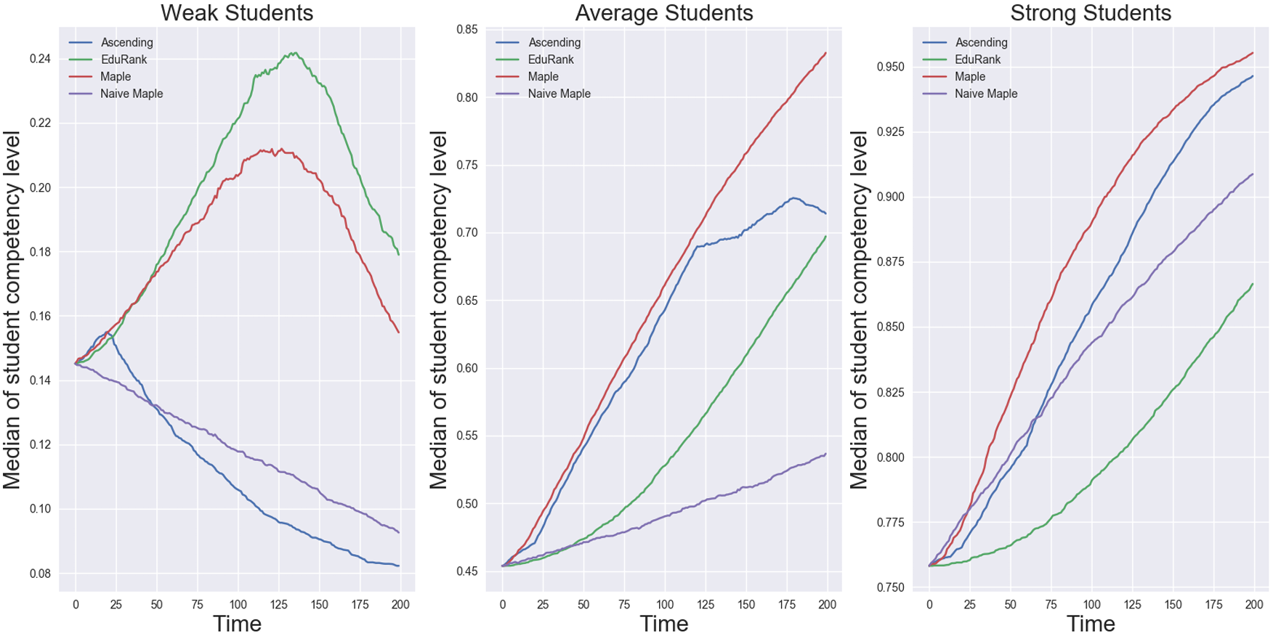

Figure 1.1: Skill level progression per algorithm and student type (Segal et al., 2018).

To enhance adaptive learning systems that leverage Deep Reinforcement Learning (DRL), we propose investigating how question format effectiveness can better inform student behavioural modelling and improve RL decision-making processes. Our approach recognizes that different question formats require varying levels of cognitive competence and can serve as reliable indicators of student learning states. By incorporating format-specific behavioural patterns into the RL environment, the system can make more nuanced decisions about content delivery, ultimately improving knowledge retention outcomes. This format-aware approach also enables the DRL agent to understand not only what students know but also how they process and respond to different types of cognitive challenges, leading to more sophisticated and effective personalized learning pathways.

1.4 Existing Systems and Approaches
Personalized learning has long been a focus of intelligent tutoring systems (ITS). Early methods, such as Bayesian Knowledge Tracing (BKT) (Baker et al., 2008) modelled student mastery probabilistically, while more recent approaches like Deep Knowledge Tracing (DKT) (Piech et al., 2015; Sonkar et al., 2020) employed recurrent neural networks to predict learning progress. These models improved student performance estimation but were often paired with static sequencing strategies, limiting adaptability to evolving student needs.

To overcome these limitations, reinforcement learning (RL) has been applied to curriculum sequencing. For example, MAPLE used Multi-Armed Bandits to adaptively choose skills and difficulty levels, consistently outperforming linear or naive sequencing (Segal et al., 2018). Other RL-based frameworks have optimized curriculum order and difficulty adjustments (Le et al., 2014), highlighting RL’s potential to personalize instruction through sequential decision-making. However, most RL-driven approaches primarily emphasize skills and difficulty, without incorporating the role of question formats as learning signals.

Parallel research in Natural Language Processing (NLP) has explored generating diverse educational content, ranging from automatic question generation (Mulla and Gharpure, 2023) to semantic alignment of content with curriculum objectives.

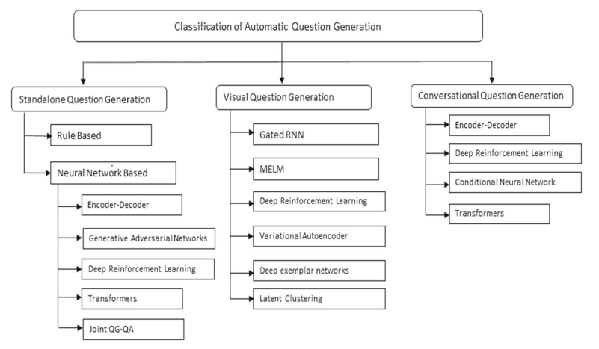

Figure 1.2: Classification of automatic question generation (Mulla and Gharpure, 2023).

A smaller set of studies has investigated combining predictive modelling with RL adaptation. For example, evaluated DKT approaches across several educational datasets and simulated sequencing environments, demonstrated potential synergies between student modelling and adaptive policies (Gervet et al., 2020).

In contrast to prior work, this study focuses on multi-type question sequencing, extending RL frameworks beyond skill and difficulty optimization to incorporate content or question format. By aligning content sequencing with curriculum objectives and leveraging behavioural modelling, this research addresses a gap in existing adaptive systems and offers a new direction for personalized learning technologies.

Chapter 2

Literature Review

2.1 Overview
Many researchers have come up with a lot of different AI techniques for increasing knowledge understanding and retention in educational settings through enhancing hints and quizzing, personalized learning paths, adaptive experimentation in educational platforms, instructional sequencing, modelling students, generating educational content and personalized education through e-learning, all following the student success framework (Tahiru, 2021).
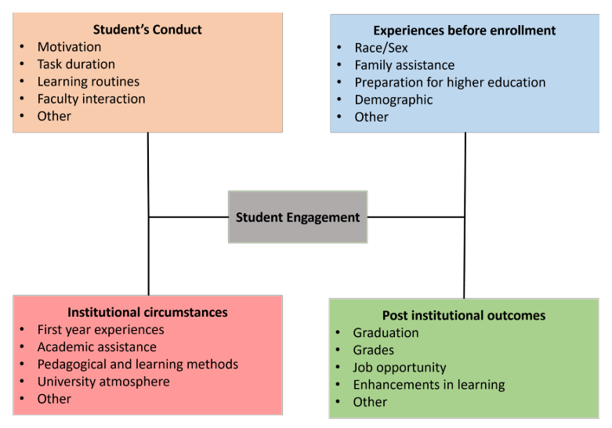

Figure 2.1: Student success framework (Tahiru, 2021).

To guide our research, we developed a relevance tree that acts as a compass for exploring the landscape of AI techniques in education with a focus on student learning outcomes. As illustrated in Figure 2.2, the relevance tree highlights the essential techniques underpinning an adaptive learning system, with a particular focus on question sequencing.

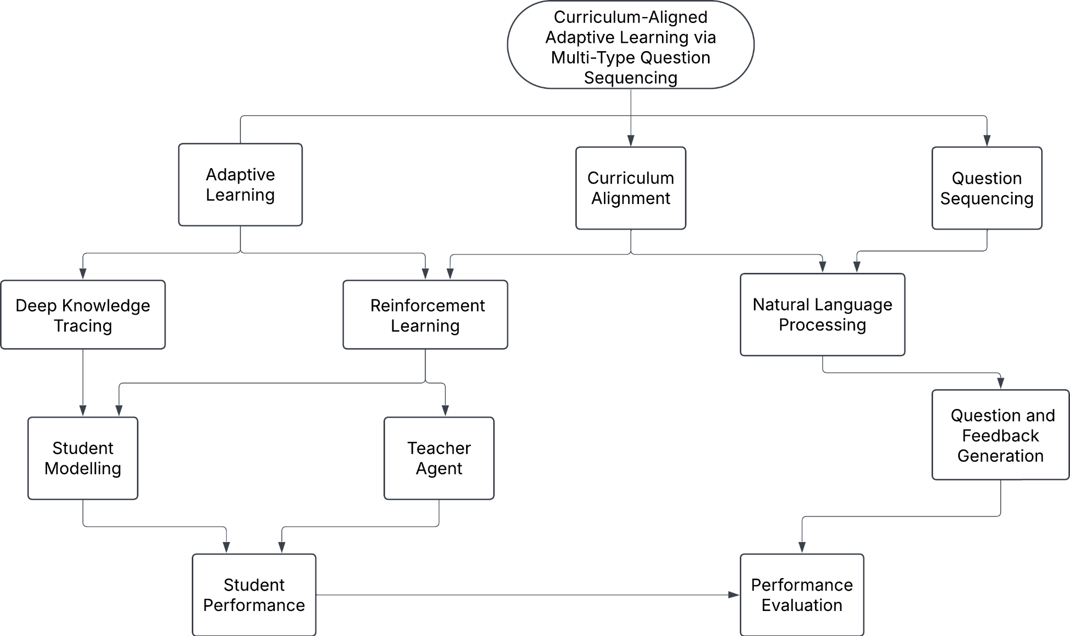

Figure 2.2: Relevance tree.

This literature review examines three interconnected domains that form the foundation of modern adaptive educational systems. First, we explore student modelling techniques, which serve as the cornerstone for personalized learning by capturing and representing individual learner characteristics, knowledge states, and learning preferences through various approaches. Second, we investigate RL techniques for question sequencing, focusing on how these algorithms optimize educational content to maximize learning outcomes by treating the educational process as a sequential decision-making problem where the system learns to adapt question difficulty and topics based on student responses and performance patterns. Finally, we examine NLP applications in educational contexts, particularly how text analysis, semantic understanding, and language generation techniques enhance student-system interactions, enable automated content analysis, and facilitate more sophisticated feedback mechanisms. Together, these three research areas represent a comprehensive framework for developing ITS that can provide truly personalized and effective learning experiences.

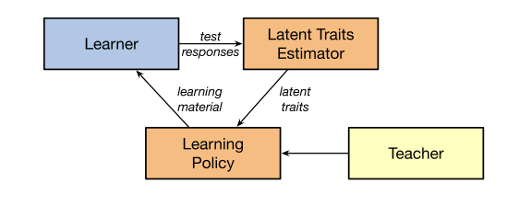

Figure 2.3: Conventional adaptive learning system (Xiao Li et al., 2020).

2.2 Student Modelling
Significant research efforts have been directed toward enhancing student learning through Knowledge Tracing (KT) (Minn, 2021)which is the process of modelling a student’s evolving understanding of concepts over time. Traditional approaches such as Bayesian Knowledge Tracing (BKT) use probabilistic models based on Hidden Markov models to estimate a student’s mastery of predefined skills (Baker et al., 2008; Shchepakin et al., 2023). More recent methods include DKT methods that leverage Recurrent Neural Networks (RNNs) and Long Short-Term Memory (LSTM) networks, to capture complex temporal dependencies in students’ learning trajectories (Piech et al., 2015). With the importance of learning duration and the increasing length of interaction sequences in adaptive learning environments, recent studies have compared LSTM-based knowledge tracing model variants with earlier methods’ variants, such as Item Cognitive Structure-KT (ICS-KT) and Self-Supervised Attentive Knowledge Tracing (SSAKT), showing that these newer approaches can achieve superior predictive performance over longer question interaction sequences (Li et al., 2024).

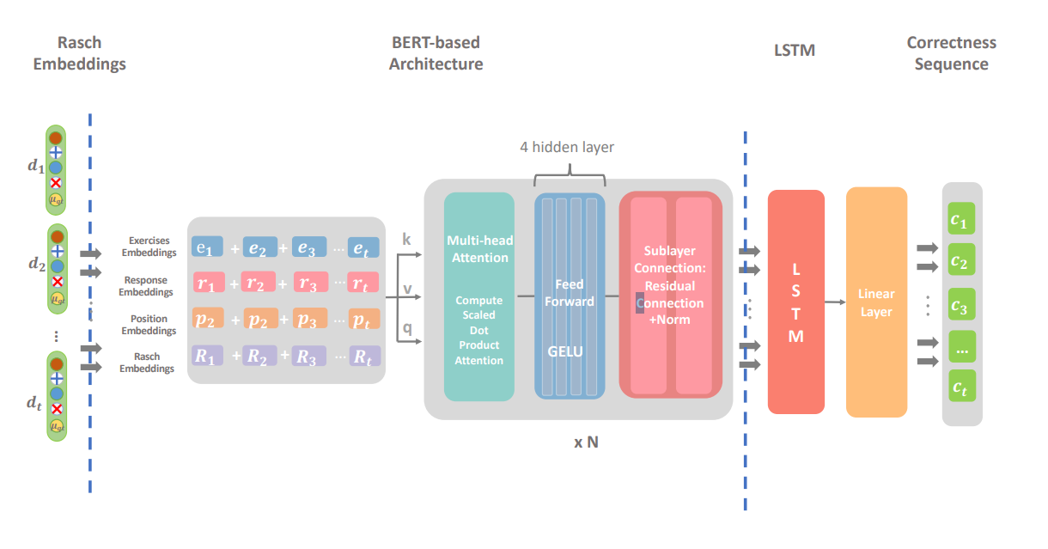

Figure 2.4: Long Short-Term Memory (LSTM)-based Knowledge Tracing (KT) architecture (Li et al., 2024).
Advancements have also introduced Graph-based Knowledge Tracing (GKT) (Nakagawa et al., 2019; Yang et al., 2020) and Transformer-based models (Choi et al., 2020), which can represent and reason over relational and sequential structures in learning data more effectively. Student learning patterns are structured over graphs with linking skills and questions to provide a point-to-point context of student learning styles and thinking processes. These graph-based representations enable more sophisticated modelling of the relationships between different knowledge components, and the pathways students take through the learning process, offering insights into individual learning trajectories and cognitive approaches to problem-solving. Students must not only master individual skills but also understand how to sequence and connect these skills to solve complex problems. Recent research has identified that successful problem-solving requires two critical components, which include finding the skills needed to answer a question among all the skills mastered, and obtaining a reasonable order of use for these skills, referred to as "skill modes" (Zhang et al., 2022). This perspective suggests that students who master individual skills but fail to establish proper associations between them may still struggle to solve problems correctly, highlighting the importance of modelling both skill mastery and the cognitive processes involved in skill sequencing and application.

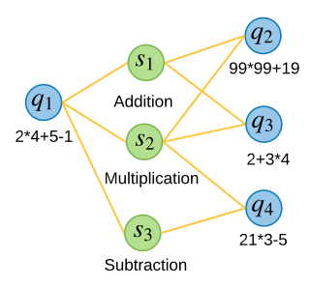

Figure 2.5: A simple example of a question-skill relation graph (Yang et al., 2020).
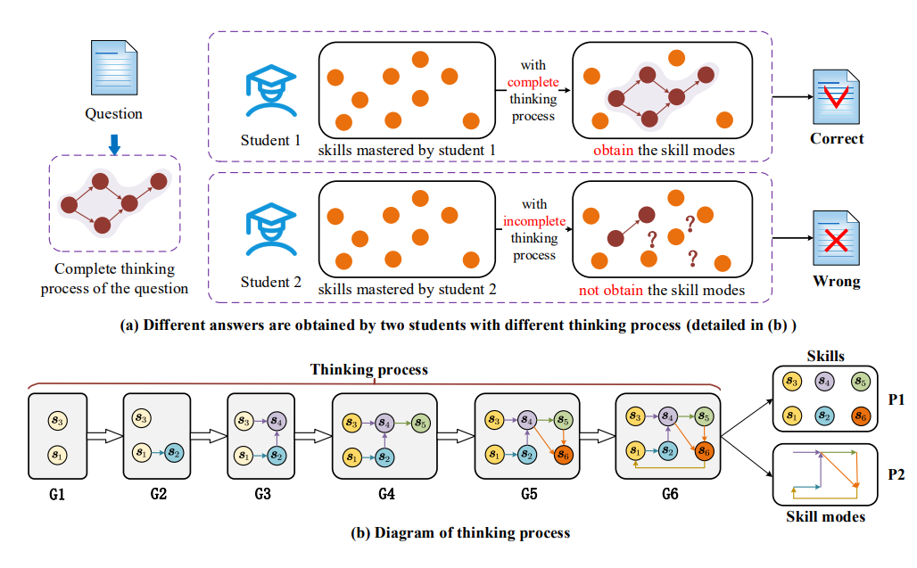

Figure 2.6: An example of Graph-based Knowledge Tracing (GKT) model (Zhang et al., 2022).

These KT techniques aim to predict the probability that a student will answer the next question correctly based on their past interactions, thus modelling what is often referred to as the student’s latent knowledge (Minn, 2021; Nakagawa et al., 2019).
However, one of the persistent challenges in this domain is the inability to generalize across diverse learners due to variations in individual learning styles, paces, and preferences (Joshi, 2023).To address this, researchers have developed models that go beyond students’ performance data by incorporating student behaviour, cognitive traits, and engagement patterns across different educational datasets (Khajah et al., 2014). Also unsupervised learning techniques such as clustering algorithms (Graf and Liu, 2009), latent profile analysis (Pastor et al., 2007), and multidimensional Item Response Theory (IRT) (Immekus et al., 2019) have been used to classify students into distinct learning style profiles, capturing traits such as visual/verbal preference, reflective/active engagement, or fast/slow learning rates. However, these methods are inherently static, as they assume that learner traits such as learning pace, learning style, or cognitive capacity remain stable over time, whereas in reality, students’ knowledge and engagement fluctuate dynamically, even within a single session (Papamitsiou and Economides, 2014).This limitation has prompted researchers to turn toward adaptive, sequential decision-making frameworks such as Reinforcement Learning (RL).

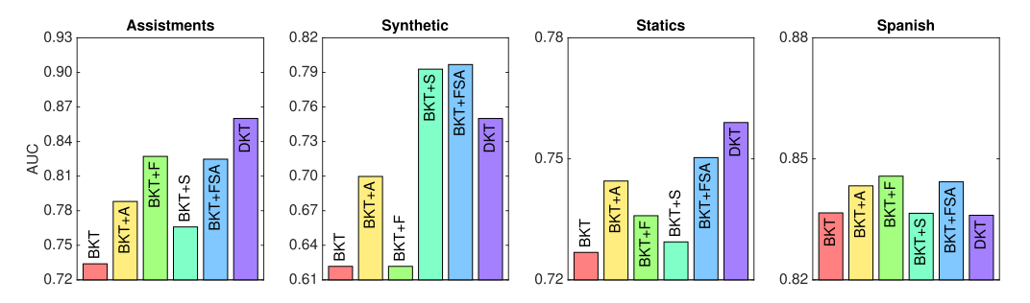

Figure 2.7: Comparative performance evaluation of six Knowledge Tracing (KT) models across four educational datasets. The evaluated models include: Bayesian Knowledge Tracing (BKT) as the baseline, BKT with latent student ability inference (BKT+A), BKT with forgetting mechanisms (BKT+F), BKT with skill discovery capabilities (BKT+S), BKT incorporating all three extensions (BKT+FSA), and Deep Knowledge Tracing (DKT) using recurrent neural networks (Khajah et al., 2014).

2.3 Reinforcement Learning in Education
RL treats personalization in education as a sequential decision-making problem, where the RL agent must select the next question or learning activity based on the student’s current knowledge or engagement state, with the ultimate goal of maximizing long-term learning outcomes as rewards (Rafferty et al., 2019). By framing educational support as a sequential decision-making problem, reinforcement learning (RL) techniques such as Multi-Armed Bandits (MAB) and Markov Decision Processes (MDP) can be used to develop adaptive instructional policies that optimize student learning outcomes over time. For example, one large-scale online tutoring system applied the MAB framework to decide which assistance action, like hints or explanations, to provide when students answered questions incorrectly. Trained on data from over one million students and evaluated across 166,000 practice sessions, the system identified policies that significantly improved both immediate second-attempt correctness and overall session performance. Offline policy evaluation was employed to assess 43,000 possible assistance actions, revealing trade-offs between optimizing for different outcomes such as correctness and session completion. MAB policies effectively optimized feedback for the general student population, increasing reattempt correctness to 0.672 ± 0.020 (baseline: 0.501), student ability to 0.105 ± 0.043 (baseline: 0.058), and session success to 0.827 ± 0.013 (baseline: 0.806). Contextual Bandit (CB) approaches, which personalized assistance based on student-specific features (e.g., prior ability, response time), showed significant improvements in reattempt correctness for 3 out of 7,548 actions and student ability for 1 action, but effect sizes were small. Well-optimized MAB policies achieved nearly equivalent outcomes, highlighting the scalability of RL-based instructional systems while leaving room for targeted personalization improvements (Schmucker et al., 2025). Additionally, in support of this thesis, the study also examined these policies for tailoring feedback to individual student features across question formats like multiple-choice, select all that apply, fill in the blank, short answer, true/false, demonstrating the potential for improved learning outcomes using question formats.
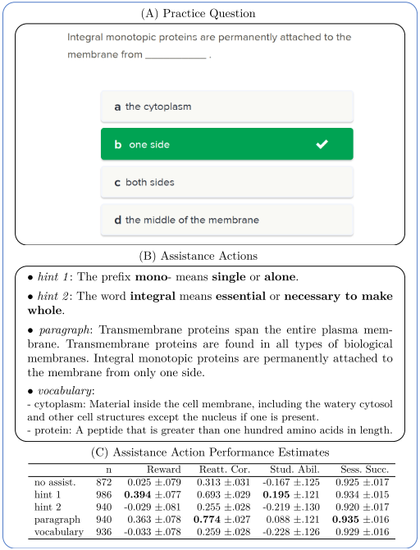

Figure 2.8: Example of assistance action evaluation for a practice question. Panel (A) shows a sample multiple-choice question. Panel (B) presents the different assistance actions provided to students, including hints, explanatory paragraphs, and vocabulary support. Panel (C) summarizes the performance estimates for each action across several learning outcome measures (Schmucker et al., 2025).
One of the key advantages of RL over static classification and KT models lies in its ability to balance exploration, i.e. introducing learners to new or challenging questions, with exploitation, i.e. reinforcing already mastered concepts. This balance enables the system to respond to learner progress in real time, refining its instructional strategy with every interaction (Wang et al., 2019). Unlike KT approaches that rely heavily on predefined learner categories, RL continuously updates its policy as new data about the learner becomes available, making it well-suited for the dynamic and context-sensitive nature of learning, leading to deep reinforcement learning models being integrated with KT frameworks to enhance the prediction of student performance and adaptively sequence tasks accordingly.
A researcher demonstrated how Proximal Policy Optimization (PPO) can be effectively integrated with knowledge tracing models to create dynamic learning path recommendations that adapt to individual student progress and performance patterns (Chen et al., 2023). Their approach leverages PPO's stable policy updates and sample efficiency to navigate the complex decision space of educational content sequencing, where the agent must balance exploration of new learning materials with exploitation of proven effective pathways. The significance of PPO in this context lies in its ability to handle the high-dimensional state spaces typical of educational environments while maintaining stable learning dynamics, making it highly appropriate for educational applications where consistent and reliable adaptation is crucial for student success. This work establishes PPO as a viable approach for educational reinforcement learning, providing a foundation for more sophisticated adaptive learning systems that can dynamically adjust learning trajectories based on real-time assessment of student knowledge states.
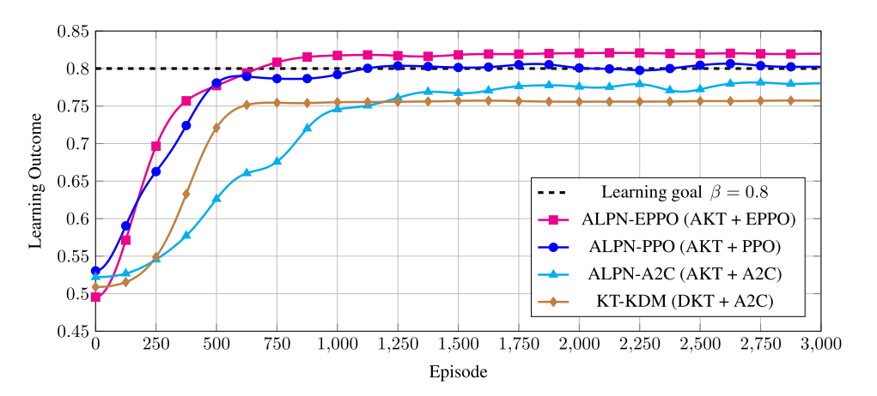

Figure 2.9: Student learning outcomes across variants of the Adaptive Knowledge Tracing (AKT) system, where the Proximal Policy Optimization (PPO) algorithm demonstrates superior performance compared to other adaptive learning approaches (Chen et al., 2023).
This research also signifies the growing potential of reinforcement learning approaches in creating truly adaptive educational systems that can respond dynamically to individual student needs in personalized feedback and tutoring, curriculum sequencing, and adaptive question recommendation.

2.4 Natural Language Processing in Education
Enhanced RL techniques have also been integrated with Natural Language Processing (NLP) to generate better questions as compared to the Stanford Question Answering Dataset (SQuAD) benchmark, by directly optimizing evaluation metrics such as such as BLEU (Bilingual Evaluation Understudy) and ROUGE (Recall-Oriented Understudy for Gisting Evaluation) instead of relying solely on cross-entropy loss. These methods reduce exposure bias, improve semantic relevance, and ensure that the generated questions are grammatically correct and contextually aligned with the given course content and answer. By combining reinforcement learning with deep neural architectures like sequence-to-sequence models, graph-based encoders, and attention mechanisms, researchers have achieved significant improvements in fluency, diversity, and answerability of generated questions, pushing the boundaries of automated question generation in NLP (Chen et al., 2020).
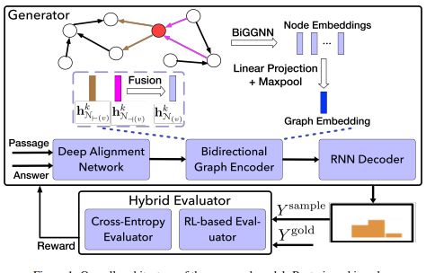

Figure 2.10: Model architecture for Reinforcement Learning (RL) enhanced question generation system (Chen et al., 2020).
The paper introduces a hybrid deep learning approach where they encode text passages as graphs using a bidirectional GNN, align answer information directly into that graph representation, and train with a mixed loss combining cross-entropy and reinforcement learning which significantly enhances the quality of generated questions from text and highlights the dynamic role of NLP in supplying data for reinforcement learning architectures.
An example of a more NLP-focused implementation in intelligent tutoring systems was achieved through a sophisticated three-step process that significantly improved student learning outcomes through NLP-driven personalized feedback (Kulshreshtha et al., 2022).The system first employed a cause-effect error classifier that decomposed both student responses and reference solutions into their constituent parts which consists of the "cause" which is the explanation/reasoning and "effect" which is the main answer by using Bidirectional Encoder Representations from Transformers (BERT) based similarity analysis to identify four types of errors: incorrect cause with incorrect effect, correct cause with incorrect effect, incorrect cause with correct effect, and missing cause with correct effect. Then, a few-shot neural question generation model, trained on expert-annotated data and enhanced with a re-ranking system, generated personalized natural language questions targeting the specific deficiencies in student responses. Finally, the system provided tailored feedback templates that acknowledged correct components while guiding students toward missing or incorrect elements through strategic questioning. This approach proved remarkably effective in improving student learning gains, outperforming minimal feedback baselines by 45% and even surpassing personalized human-crafted feedback by 23% when tested with 146 real student interactions across 550 exercises in the Korbit ITS platform. The system's success stemmed from its ability to move beyond generic hints to provide precise, component-specific guidance that helped students understand not just what was wrong, but how to think through the correct reasoning process.

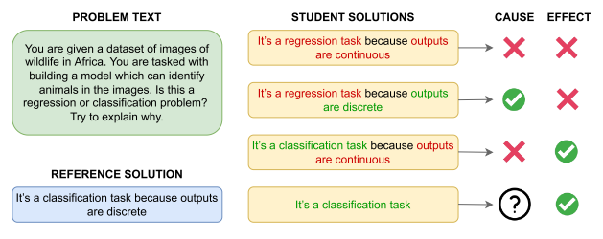.

Figure 2.11: Classification of student responses to cause-effect questions using Natural Language Processing (NLP) (Kulshreshtha et al., 2022).

2.5 Gaps and Motivation
Although several studies have explored the classification of students, sequencing and optimizing of learning paths and questions based on learning styles, little attention has been paid to the role of interaction with multi-type questions or content formats (e.g., algebra, cloze, fill in the blank, multiple choice) in predicting student performance or enhancing learning outcomes. These questions or content types may assess the same underlying skill or concept but often demand varying levels of knowledge or cognitive effort from students (Hadifar et al., 2023).
The proposed approach involves a student model that classifies learners into skill mastery profiles based on interaction patterns and question formats from the ASSISTments 2009 dataset, thereby informing more precise student latent knowledge. A teacher agent integrated within the RL framework interacts with the student agent and leverages the capabilities of LLM models to select and tailor different question types to optimize the sequencing and formats of questions presented to the student agent.
By integrating NLP for the generation of educational content with the adaptive decision-making power of RL based on question formats, this research seeks to advance the field of personalized learning. Ultimately, it offers valuable insights into the design of an ITS capable of adapting to the unique needs, preferences, and progress of each student. Our objective of this thesis is to answer the following research questions.
- How well can a knowledge tracing model predict student understanding of concepts based on their responses to different question types?
- Can a reinforcement learning model adaptively select and sequence question types to improve student performance over time?
- Can multi-type question sequencing lead to more personalized and effective learning experiences?

Chapter 3

Methodology

3.1 Data Acquisition
This study employed the ASSISTments 2009–2010 dataset, a widely recognized benchmark in educational data mining and knowledge tracing research (Gervet et al., 2020; Sonkar et al., 2020; Xiong et al., 2016). The dataset comprises 603,128 student interaction records and includes 30 distinct features, such as order ID, assignment ID, user ID, original answer, correctness, attempt count, answer type, sequence ID, skill name, hint count, total hints, overlap time, template ID, answer ID, answer text, first action, covering student and problem identifiers, skill tags, timestamps, and detailed performance metrics.

A particularly important feature is the answer type column, which can be better referred to as question type, which specifies the format or type of each question presented to students. This field enables differentiation between question styles, which can influence student engagement and models’ performances. The question formats available in the dataset included the following:
- Choose One – Multiple-choice questions where the learner selects one correct answer from several options.
- Algebra Questions – Questions requiring algebraic computations or solving equations, often with numerical or symbolic answers.
- Fill in One – Questions where the learner types a single answer into a blank, usually a number, word, or short phrase.
- Open Response – Questions that allow learners to write free-form text or explanations, assessing deeper understanding.
- Rank Questions – Questions where learners order items or steps correctly, testing logical or procedural understanding.
- Choose Multiple – Multiple-choice questions where learners select two or more correct answers from a set of options.

3.2 Data Preprocessing
To build an effective knowledge tracing model, we began by exploring student interaction data from the ASSISTments 2009–2010 dataset. A critical feature in the dataset for our model was the answer type, which specifies the type of question each student engaged with. The dataset comprised 238,288 choose one questions, 203,906 algebra questions, 114,870 fill-in-one questions, 586 open response questions, 164 rank questions, and 33 choose multiple questions.
To mitigate the effects of data imbalance and avoid biased model performance, we limited our analysis to the three most frequent question types: choose one, algebra, and fill in one. The remaining types were excluded due to their extremely low representation, which would have introduced variance and hindered the model's ability to generalize effectively. We also corrected typographical errors in the skill name column, as this adjustment was essential to prevent inaccurate results when applying NLP models for question generation and semantic analysis.
To better understand the structure of the dataset and assess the potential complexity of the sequences involved in DKT, we visualized the distribution of question types across different skills using a heatmap. The plot reveals that certain skills are disproportionately represented, particularly in “choose one” question types. This skew suggests that the dataset is imbalanced, with a concentration of student interactions around a subset of skills and question formats. On the other hand, many skills show sparse coverage across question types, indicating variability in how skills are assessed.
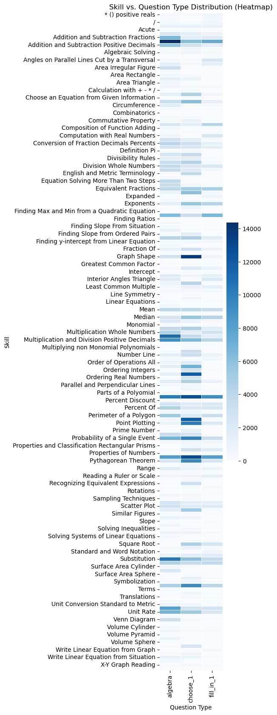

Figure 3.1: Skill vs question type distribution heat map in the Assistments 2009 Dataset.

While this imbalance could potentially bias the DKT model towards more frequently occurring skills, it also reflects realistic learning environments where some topics receive more practice than others. Rather than applying artificial balancing techniques that might discard valuable data, we chose to retain the natural distribution. This decision allows the model to better reflect actual student learning behaviour and engagement patterns, especially since DKT is designed to work well with uneven temporal sequences. However, the observed sparsity in low-frequency skills should be considered when evaluating the model’s generalization, especially for underrepresented concepts.
Each student interaction record included a correctness score, representing the student’s performance on a particular question. Unlike traditional binary correctness labels (0 or 1), the dataset includes partial credit scores such as 0.25, 0.5, and 0.7 to reflect varying degrees of correctness. For this thesis, we converted these continuous values into binary labels using a threshold of 0.5 such that responses with scores equal to or greater than 0.5 were considered correct, while those with scores below 0.5 were considered incorrect. This binarization allowed the model to operate within a standard binary classification framework and accommodate the input sequence encoding for our student model.
Another key temporal feature in the dataset was the order ID, which indicates the sequence in which exercises were presented to each student. This ordering was essential for sequential modelling, particularly for our Bidirectional LSTM (BiLSTM) architecture, which captures both past and future context to infer the student's evolving knowledge state and improve the accuracy of future performance predictions.
In cases where a question was associated with multiple skills, rather than combining them into a composite skill as done in some prior work (Xiong et al., 2016), we instead treated each skill independently. We generated a separate input sequence entry representing each different skill relating to a question. Correspondingly, the target output was one-hot encoded for all skills associated with the question to indicate the student’s mastery of each relevant skill. This approach allowed the model to track knowledge states at the individual skill level, ensuring that each skill's contribution to the student's learning trajectory was captured distinctly. All records without any associated skills were removed, as they could not contribute to skill-level learning.
To ensure that the sequences provided sufficient information for effective temporal modelling, we analysed the distribution of skill interactions per student in the dataset. We observed that many students had interacted with only a small number of unique skills. To address this issue while still preserving meaningful sequential data for DKT, we decided to exclude students with fewer than 10 recorded interactions. This threshold was chosen to eliminate extremely short sequences, which typically hinder the learning performance of recurrent models due to limited contextual information.
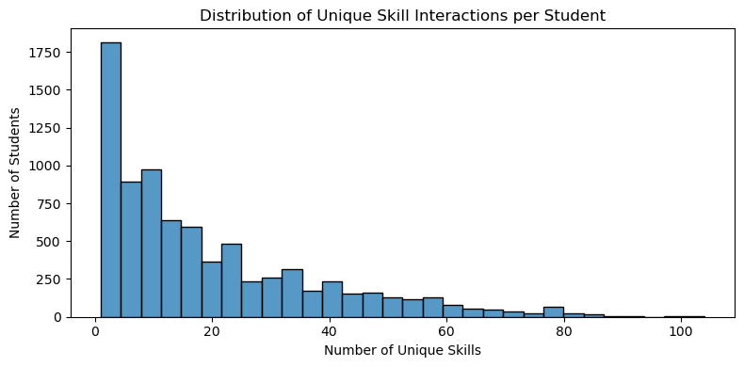

Figure 3.2: Distribution of unique skills interactions in the Assistments 2009 Dataset.

To ensure the temporal integrity of the data and preserve the natural learning progression of each student, all interaction records were sorted by user ID and order ID. This chronological ordering is critical in the context of DKT, as the model relies heavily on the sequence of interactions to learn how student knowledge evolves. Maintaining this order allows the recurrent architecture, particularly LSTMs, to capture temporal dependencies and model knowledge state transitions effectively.

3.2.1 Sequence Windowing and Length Selection
An analysis of the dataset revealed an average of 87.96 interactions per student, with the minimum number of recorded interactions being 10, due to our earlier preprocessing threshold and a maximum of 1036 interactions per student. To standardize input sequences while still preserving sufficient contextual information for the model to learn from, we also conducted hyperparameter tuning experiments with sequence lengths of 50, 100, 150, 200, and 250. The goal was to assess how varying sequence lengths affect the model’s performance across key evaluation metrics, which include Area Under the Receiver Operating Characteristic Curve (AUC), precision, and recall. Notably, the 90th percentile for interaction length per student was 229.90, indicating that a significant portion of students had long enough histories to support extended sequences. However, the sequence length of 50 struck the best balance between predictive performance and computational efficiency. Table 3.1 shows the detailed results from this tuning experiment is provided below. A maximum sequence length of 50 yielded the highest AUC, precision, and recall, while also resulting in the fastest training time. As the sequence length increased beyond this point, a gradual decline in performance metrics was observed.

Table 3.1: Sequence length hyperparameter tuning results
Sequence Length | AUC | Precision | Recall
50 | 0.9920 | 0.9902 | 0.9622
100 | 0.9904 | 0.9873 | 0.9535
150 | 0.9894 | 0.9865 | 0.9505
200 | 0.9897 | 0.9863 | 0.9496

Therefore, sequences shorter than 50 were padded appropriately, ensuring that they conformed to the input size expected by the model without introducing noise. Meanwhile, for students with longer interaction histories, we employed a sliding window approach to segment their sequences into fixed-length windows of 50 interactions. This method allows the model to learn from multiple overlapping segments of a student's learning history, rather than relying solely on the most recent interactions. By using a windowed sequencing strategy, we preserve a broader range of interaction patterns over time and increase the effective training data, as each window serves as a distinct sequence for the model to process. This approach not only retains the temporal structure within each window but also helps the model better capture knowledge transitions across different stages of a student’s learning trajectory.
This decision strikes a balance between capturing meaningful temporal patterns and maintaining computational efficiency. Using a fixed sequence length also simplifies batching during training, leading to more stable convergence. Overall, this preprocessing step supports the model's ability to generalize and make accurate predictions of future student performance.

Table 3.2: Dataset description after preprocessing
Dataset | No of question interactions | No of unique skills | No of question types | No of unique students | Average Frequency of unique student interactions | Maximum Frequency of unique student interactions | Minimum Frequency of unique student interactions | No of unique question type-skill interaction
Assistments 2009/10 | 549020 | 174 | 3 | 6242 | 87.96 | 1036 | 10 | 1019

3.2.2 Question Generation
For the reusability and stability of our environment, we opted not to dynamically generate questions at each timestep. Instead, we constructed a question bank of 1,000 questions using Claude Sonnet 4. These questions encompass a variety of formats, skills, and difficulty levels, carefully aligned with the skills represented in the ASSISTments 2009 dataset. To ensure balanced representation, the questions were equally distributed across all relevant skills and question types on which our student agent was trained on. To prevent redundancy and avoid null errors, when the teacher agent selects a specific skill and question type, it randomly samples from the pool of available questions associated with that skill–type pair at each timestep.

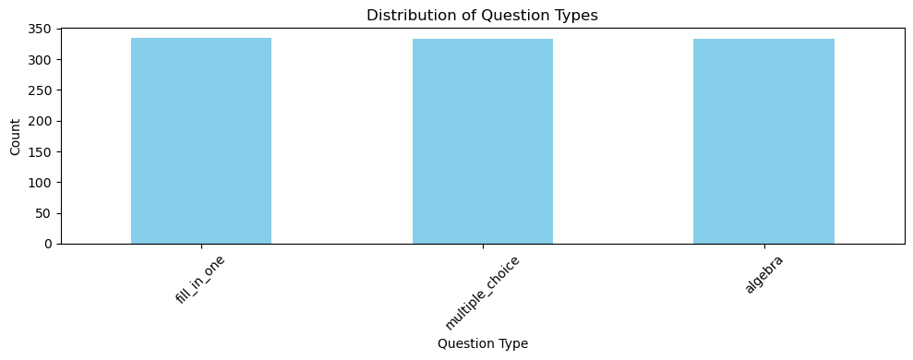

Figure 3.3: Distribution of question types in the generated question bank.
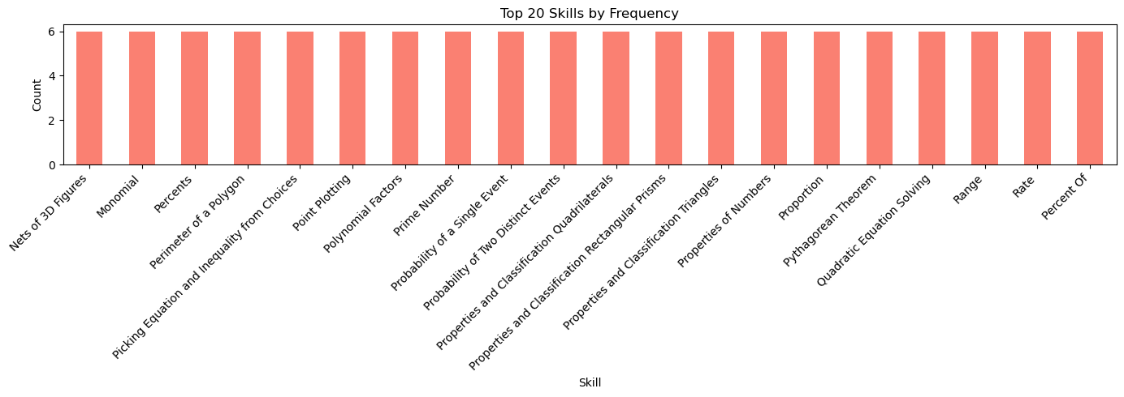

Figure 3.4: Distribution of top 20 skills in the generated question bank.

3.3 Models and Algorithms
To enable the adaptive learning experiment, several key encodings, models and algorithms were deployed. These components worked together to simulate a student's learning process and a teacher's adaptive decision-making via multi-type question sequencing.
3.3.1 Question Interaction Sequence Encoding
To enrich the student model's input with contextual information about the nature of each question, we incorporated the question type into the skill encoding scheme. The encoded input for each time step was computed using the following formula:
$x$_{encoded} = $s +c.N$ (1)
$x$_{encoded + qt} = $x$_{encoded} $+q(2N)$ (2)
where:
- $x$_{encoded} is the encoded question input with skill and correctness.
- $x$_{encoded + qt} is the enhanced encoded question input with question type integrated.
- $s$ is the skill ID.
- $c$ ∈ {0, 1} is the correctness label.
- $q$ is the question type index.
- $N$ is the total number of unique skills
This encoding strategy captures three critical aspects of each student interaction: the specific skill being assessed, the correctness of the student's response, and the type of question presented. By integrating these components, the model gains a more nuanced and context-aware representation of the learning process. Unlike traditional DKT models, which often treat all skill interactions or question interactions uniformly (Piech et al., 2015; Sonkar et al., 2020), this approach enables the model to differentiate between variations in question format, for example, distinguishing between a multiple-choice question and an algebraic input question targeting the same skill. Such distinctions are valuable, as they may reflect different cognitive demands and levels of student mastery. All unique student interaction sequences were padded to a fixed maximum length of 50 to enable efficient batch processing. The target for each interaction time step was a one-hot vector indicating the correctness of the next skills attempted by the student.
We later compared the two encodings from Equations (1) and (2), representing the traditional DKT and the question type enhanced DKT, to evaluate whether incorporating question type information improves the model’s ability to predict student performance.

3.3.2 Student Model - Deep Knowledge Tracing
The student performance prediction model is built upon a recurrent neural network architecture specifically designed for the knowledge tracing task. Following the DKT framework, the model incorporates embedding layers and LSTM units to effectively capture temporal dynamics within students’ learning trajectories.
At the input stage, skill identifiers and question types are embedded into a 384-dimensional dense vector space. These embeddings are initialized using the pretrained sentence-transformers model all-MiniLM-L6-v2, a lightweight BERT-based architecture optimized for generating sentence embeddings, which is fine-tuned for semantic similarity tasks. Leveraging these pretrained embeddings enables the model to capture subtle semantic relationships among skills and question types. Comparative experiments showed that pre-trained embeddings offered improved convergence speed and slightly better predictive performance than randomly initialized embeddings, motivating their adoption in the final model.
To capture sequential dependencies in student interactions, both unidirectional and bidirectional LSTM layers were evaluated. The bidirectional LSTM consistently outperformed the unidirectional variant by accessing information from both past and future contexts in the input sequence. This bidirectional capability proved critical for handling varying length student histories, allowing the model to better infer knowledge states and predict responses more accurately.
Therefore, the model can be expressed as:
$xₜ = Embedding(sₜ, cₜ, qₜ)$ (3)
$hₜ = BiLSTM(xₜ)$ (4)
$ŷₜ = σ(W·hₜ + b)$ (5)
Where:
- $sₜ$​ represents the skill identifier at time step $t$ , i.e. the specific concept or skill the student interacted with.
- $qₜ$ represents the question type at time step $t$ , i.e. the format of the question (e.g., multiple choice, algebra, fill-in).
- $cₜ$ represents the correctness of the attempt at the time step $t$
- $σ$ is the sigmoid function
- $W$ and $b$ are the output layer’s weights and biases
- $xₜ$ is the input embedding at time step, $t$, representing the skill, question type and correctness
- $hₜ$ is the hidden state from the Bidirectional LSTM at time step, $t$
- $ŷₜ$ is the predicted probability of a correct answer across all skills at time step, $t$
Key hyperparameters of the model were optimized through an extensive grid search process. The final selected configuration included a single layer of 128 Bidirectional LSTM units with a dropout rate of 0.2 and a learning rate of 0.0025. The integration of pretrained semantic skill-question type embeddings with a bidirectional LSTM architecture allows the model to effectively capture diverse learning behaviours, adapt to different question types, and accommodate varying skill complexities and relationships.
The model processes sequences comprising student interactions with specific skills and question types. For each time step, it outputs the probability of a correct response to the subsequent exercise associated with each skill. The prediction layer employs a sigmoid activation function, enabling multi-label classification at every time step. Model training was performed using the Adam optimizer, with binary cross-entropy serving as the loss function to guide parameter updates.
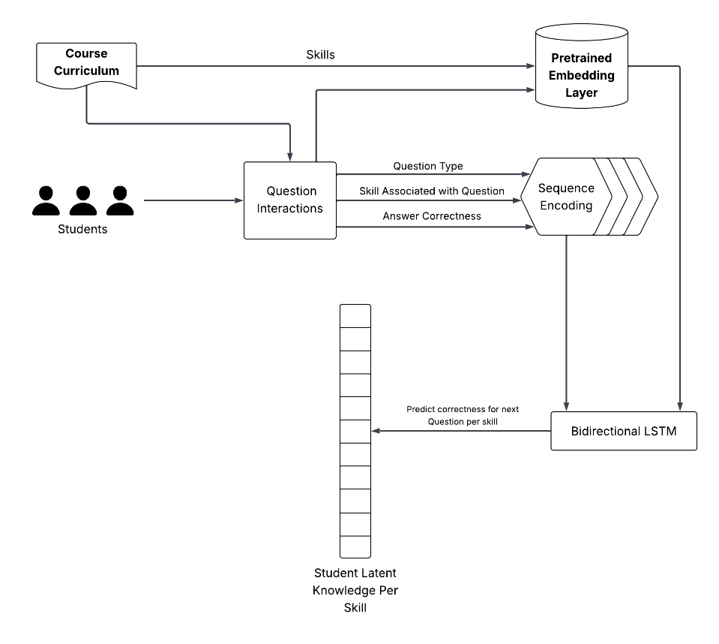

Figure 3.5: Student agent’s Deep Knowledge Tracing (DKT) structure.

3.3.3 Reward Function
To simulate realistic learning interactions, the environment gets its reward from both the questions selected and the dynamic student model. Questions are generated using Sonnet 4 LLM (Anthropic, 2025), conditioned on the selected skill and question type to ensure contextual relevance. Each generated question is then embedded using Sentence-BERT (SBERT) for semantic analysis and archived for evaluation in rewards. The student's learning trajectory is modelled using the pre-trained student model, which updates the predicted knowledge state after each question interaction.

Table 3.3: Reward function description for question selection environment.
Reward Component | Description | Computation
Improvement | Predicted average learning gain after each step | The difference between the last and the previous average student agent’s performance
Answerability | The likelihood that the student can answer the question correctly | Weighted average of predicted performance on top-k relevant skills to question
Curriculum Coverage | Focus on underdeveloped (weak) skills | If the selected question targets the student agent's weakest skills

The reward function in Table 3.3, which considers question answerability, performance improvement, and curriculum coverage based on student performance, can be related to the reward design of Guan et al., (2023). Their model incorporates naturality, relevance, answerability, and difficulty. Both approaches share answerability as a key factor but differ in emphasis. Guan et al. focus on linguistic and semantic quality through naturality and relevance to educational documents, while the Table 3.3 design is grounded in educational practice, prioritising curriculum alignment and measurable performance improvement. Moreover, Guan et al. rely on automated metrics, whereas Table 3.3 leverages real student outcomes. In essence, both use multi-dimensional rewards, but with distinct orientations i.e. linguistic optimisation versus pedagogical effectiveness.
Each reward function plays a critical role in guiding the system toward meaningful and personalized interactions. The performance improvement reward is essential because it ensures that the system prioritizes questions that lead to measurable learning progress, such that when the student agent shows an increase in predicted skill mastery, it indicates that the selected questions are effectively contributing to their development. Answerability, on the other hand, maintains the delicate balance between challenge and achievability. By estimating the likelihood that a student can correctly answer a given question based on relevant skills to the question, the system avoids overwhelming them with overly difficult content while still pushing their boundaries, keeping them engaged and motivated. Curriculum coverage further enhances learning by focusing attention on weaker areas in a student’s skill profile, ensuring that the system doesn’t overfit to strengths but instead helps build a more well-rounded understanding. Altogether, these reward signals work in harmony to drive continuous, targeted learning while safeguarding the user experience and curriculum coverage.

3.3.3 Question Selection Environment
To enable adaptive curriculum sequencing and personalized learning, a custom RL environment was developed. This environment simulates interactions between a teacher agent using the PPO algorithm and the student agent modelled using a DKT approach.
The environment design centres around two key components: the observation and action spaces. At each timestep, the environment provides the teacher agent with a normalized skill mastery vector, where each value ranges between 0 and 1. This vector represents the teacher agent’s current belief about the student agent’s competence across all predefined skills, effectively serving as the observation space for learning. The action space is defined as a pair of skill identifier and question type, allowing the agent to select both the specific skill to target and the format of the question to present. This dual selection mechanism supports adaptive personalization, enabling the teacher agent to tailor both the content and delivery method to the student's evolving needs. The environment is designed to simulate realistic tutoring dynamics and consists of the following key components:
- Observation Space: At each timestep, the environment provides the teacher agent with a normalized skill mastery vector. Each element of the vector ranges from 0 to 1 and represents the model’s current estimate of the student’s probability of answering a question relating to each skill correctly. This vector acts as the teacher agent’s belief state of the student agent’s knowledge and captures the evolving knowledge profile of the learner.
- Action Space: The action space is defined as a pair of discrete variables which includes the target skill and its question type. To support ablation experiments, the environment can also be configured in constrained modes:
  - Skill+Type Mode: The agent selects both skill and question type, which makes it fully adaptive.
  - Skill-Only Mode: The agent selects only the skill, while the question type is sampled randomly.
  - Random Mode: Both skill and question type are randomly sampled, serving as a non-adaptive baseline.
- Reward Weights: The reward mechanism is designed to balance pedagogical objectives and stable training dynamics. It is computed as a weighted sum of three components as described in Table 3.3. Each component is scaled by tuneable weights to balance their relative importance. This ensured that no single component disproportionately influenced the total reward, thereby preventing reward exploitation and promoting balanced policy learning.
- Environment Parameters: Other environment parameters were created and hyper tuned to optimize training efficiency and policy quality
- Maximum steps per episode: Defines the upper limit of interactions within a single episode, thereby controlling its overall question interaction with the student agent before resetting the environment and the student agent’s knowledge state.
- Top K relevant skills to question: Defines the number of most relevant skills identified using the BERT sentence-transformer model, which are then considered when computing the answerability component of the reward by finding the average of the student agent’s performance on the relevant skills.
- Weak skills threshold: Establishes the cutoff point for identifying underdeveloped skills, which guides the coverage reward and determines how explorative the teacher agent is at providing new skills to the student agent to learn.
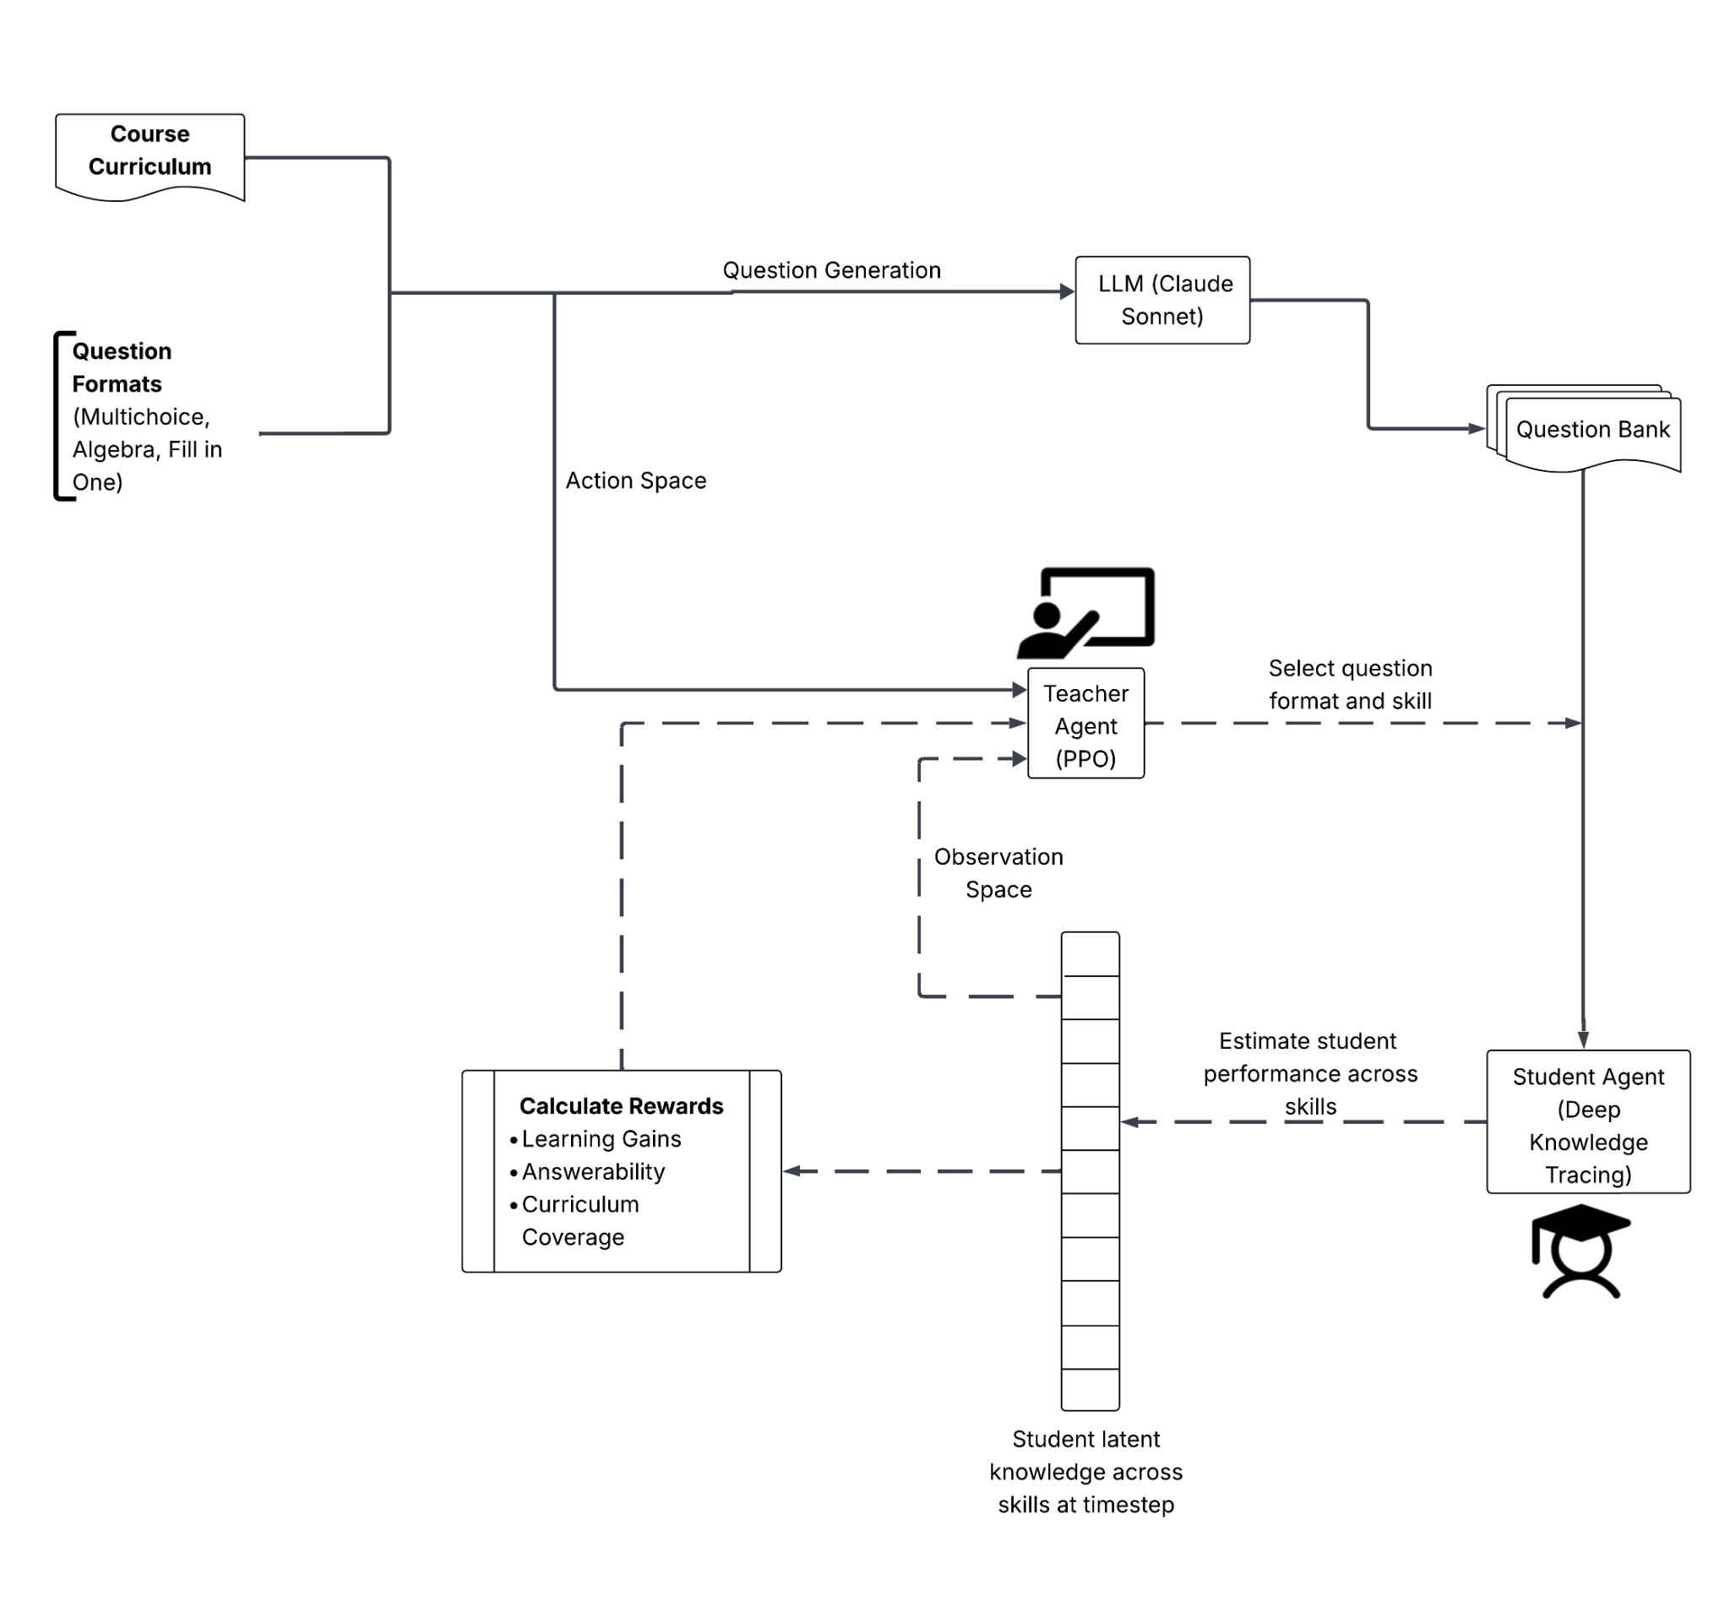

Figure 3.6: Question selection environment structure.
This RL environment provides a robust and extensible framework for investigating adaptive multi-type question sequencing policies. It selects from an already generated bank of 1,000 questions, derived from the ASSISTments dataset curriculum and spanning skill levels from easy to hard, with balanced question types for each skill. The bank was generated using a carefully designed prompt to the Claude LLM to ensure verified questions, thereby enabling reusability and ensuring stability of results. It also enabled systematic comparison between fully adaptive (with skill question type), partially adaptive (skill-only), and non-adaptive (random) sequencing strategies, ensuring that the experimental results reported are grounded in a well-defined and reproducible setup. The teacher agent and environment parameters were systematically tuned across key hyperparameters, including learning rate, discount factor, batch size, reward weights, and the exploration–exploitation strategy. The final configurations, presented in Tables 3.4 and 3.5, were selected to achieve stable convergence and consistent learning gains across validation experiments.

Table 3.4: Hyperparameters and their values for the question selection environment.
Hyperparameter | Description | Value
max_steps | Maximum steps (questions) per episode | 250
top_k | Number of relevant skills to question considered for answerability | 3
weak_skills_threshold | Proportion of skills considered underdeveloped for curriculum coverage calculation | 0.4
action_types | Defines question selection mode by question type and skill, only skill or none | ['type', 'skill']
w_improvement | Weight for improvement component in the reward function | 100
w_answerability | Weight for the answerability component in the reward function | 50
w_coverage | Weight for the curriculum coverage component in the reward function | 0.5
question_types | List of available question types | ["Algebra", “Fill in Blank”, “Multiple Choice”]
all_skills | List of all skills in the environment | Skills from the Assistments 2009 dataset
dkt_model_path | Path to pretrained student DKT model | -
max_seq_len | Maximum sequence length for student model input | 50

Table 3.5: Hyperparameters and their values of Proximal Policy Optimization teacher agent
Hyperparameter | Description | Example Value
learning_rate | Step size for policy updates; lower values = slower, more stable learning | 0.0004
clip_range | Limits how much the policy can change per update; prevents large jumps | 0.25
vf_coef | Weight for value function loss; higher = more focus on value prediction | 0.7
gae_lambda | Controls how much future rewards are considered in advantage estimation | 0.95
gamma | Discount factor for future rewards; higher = more focus on long-term learning outcomes | 0.99
ent_coef | Entropy coefficient; encourages exploration, higher = more random actions | 0.05
batch_size | Number of samples per update; larger = more stable gradients, slower updates | 256
n_steps | Number of environment steps to collect before each update | 2048
max_grad_norm | Clips gradients to prevent exploding updates; improves stability | 0.5
target_kl | Stops training early if policy changes too much; helps prevent instability | 0.03
n_epochs | Number of passes over each batch per update; higher = more thorough learning | 10
policy_kwargs | Network architecture for policy and value function | [128, 128]

3.4 Experimental Setup
In our experimental setup, we begin by assessing the influence of question type encoding on model performance. Specifically, we compare two knowledge tracing models: DKT-Skill+QType, which includes question type encoding during training, and DKT-Skill, which excludes it. After training the DKT+QType model for 12 epochs and performing the hyperparameter tuning steps described earlier, we removed the question type from the encoding to train the DKT-Skill model. The goal of this comparison is to isolate the effect of question type encoding on predictive performance and determine its effect in predicting student knowledge states.
This thesis further investigates how the format of a question influences student learning and whether adapting question formats in real time can enhance skill mastery. To explore this, we evaluate and compare three distinct policies within a simulated learning environment powered by the trained DKT student model. The first and most expressive policy uses a PPO agent trained to adaptively select both the skill and the question type at every step. By aligning question presentation with individual learning needs, this method leverages the pedagogical potential of question format to support deeper comprehension and sustained learning gains.
To isolate the impact of adaptive question format selection, we introduce a second policy, which is a PPO agent that selects only the skill, while the question type is randomly assigned. This version allows us to measure how much benefit comes specifically from adapting the format of the question, given the same underlying skill selection mechanism.
Finally, we include a random baseline policy, where both skill and question type are selected without any regard for the student's current mastery. This serves as a control, highlighting the added value of any adaptive strategy. All policies are evaluated in a shared environment where the agent interacts with a DKT-based simulated student agent, initialized from real student performance data. The agent receives reward signals that reflect learning gains, question answerability and curriculum coverage. We track performance across several key metrics, including learning gain over time, skill mastery rate, and question diversity. Below is a summary of the models and policies to be trained.
- DKT-Skill+QType - Knowledge tracing model trained with question type encoding included in the input. This serves as the baseline to assess the impact of question format on prediction performance.
- DKT-Skill - A knowledge tracing model trained without question type encoding. Used to isolate the effect of removing the question type from the model.
- PPO-Skill+QType - A fully adaptive policy where the PPO teacher agent selects both the skill and question type at each step based on the student’s current state.
- PPO-Skill - A partially adaptive policy where the PPO teacher agent selects only the skill, while the question type is randomly assigned.
- PPO-Random - A non-adaptive baseline where both skill and question type are randomly selected, providing a control for comparison.

3.5 Resources and Infrastructure
This project leveraged a range of open-source libraries and computational resources to implement, train, and analyse the reinforcement learning agent within a custom educational environment. The following libraries formed the backbone of the system:
- Claude AI: Used for the generation of verified mathematical questions of different formats with a well-detailed prompt.
- Stable Baselines3: Used extensively for implementing and training the PPO reinforcement learning agent. Stable Baselines3 provides robust, well-tested RL algorithms and seamless integration with custom Gym environments, enabling efficient experimentation and hyperparameter tuning.
- OpenAI Gym: Served as the framework for designing the custom environment, defining the state and action spaces, and managing the agent-environment interaction loop. OpenAI Gym’s modularity facilitated rapid prototyping and testing of different environment configurations.
- Pandas: Utilized for data manipulation and analysis, including for loading, filtering, and processing the question bank stored in CSV format. Pandas enabled efficient handling of the large Assistments 2009 dataset and supported exploratory data analysis.
- NumPy: Provided fast numerical operations and array manipulations throughout the environment, especially for representing student skill vectors, calculating performance metrics, and optimizing computational routines.
- Matplotlib: Used for visualizing data distributions, training progress, and evaluation results. Matplotlib supported the creation of informative plots for both exploratory analysis and final reporting.
- TensorFlow/Keras: Employed for training and running the DKT student model, which predicts student performance on various skills. TensorFlow/Keras enabled the integration of LSTM-based prediction into the RL environment.
- Scikit-learn: Used for computing cosine similarities and other statistical metrics, supporting the analysis of question relevance and skill coverage.
The project was developed and executed on a Windows-based workstation using Visual Studio Code as the primary IDE. The workstation, equipped with a 13th Generation Intel Core i9-13900H central processing unit (CPU) running at 2.60 gigahertz (GHz) and 16 gigabytes (GB) of random-access memory (RAM), was selected over Google Colab due to the latter’s limitations, such as high costs, session timeouts, and interruptions due to long training runs which took hours. In contrast, the chosen infrastructure offered sufficient computational power, stability, and development flexibility, enabling efficient execution of RL experiments and hyperparameter tuning, easier dependency management, and real-time monitoring of training progress through TensorBoard.

Chapter 4

Results

4.1 Introduction
For presenting the results, we organize this section into two subsections. First, we evaluate the performance of both the student model and teacher agent, then address our research objectives by systematically answering our research questions through an in-depth analysis of the adaptive system simulation.

4.2 Evaluation
We conduct a comprehensive performance analysis of our trained DKT model with question type encoding integration and without it. Additionally, we assess the rewards and key performance metrics achieved by our teacher agent when implementing various policies, from random selection to the most adaptive approach, to determine how question type considerations impact overall model effectiveness.

4.2.1 Student Model Evaluation
For the evaluation of our knowledge tracing model, AUC was chosen over accuracy. AUC measures the trade-off between the true positive rate and the false positive rate across all decision thresholds and is the most widely used metric for assessing learner performance models (Gervet et al., 2020). It is particularly well-suited for this task because it evaluates the model’s ability to distinguish between correct and incorrect responses across varying thresholds, providing a more robust measure of predictive performance, especially in cases where the data is imbalanced and the distribution of correct versus incorrect responses is skewed. Unlike accuracy, which relies on a single fixed threshold, AUC evaluates performance across all possible thresholds, offering a more comprehensive view of the model’s discriminative power. In the context of DKT, this is particularly important, as it reflects the model’s ability to reliably capture the nuances of student knowledge states and predict future responses. Precision and recall were also employed to further assess DKT’s performance. Precision indicates the proportion of correctly predicted positive responses out of all predicted positives, while recall measures the proportion of actual positive responses correctly identified by the model. In the context of DKT, precision highlights how reliably the model can identify when a student is likely to answer correctly, while recall reflects the model’s sensitivity in detecting true learning gains. By balancing these perspectives, we gain deeper insight into the DKT models’ abilities to accurately capture student knowledge states and provide reliable predictions for our adaptive RL system.

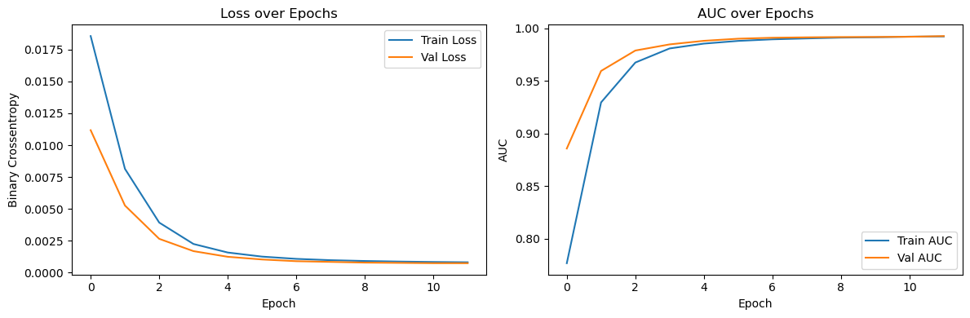

Figure 4.1: Training performance of Deep Knowledge Tracing (DKT) of student agent without question type encoding (DKT-Skill).

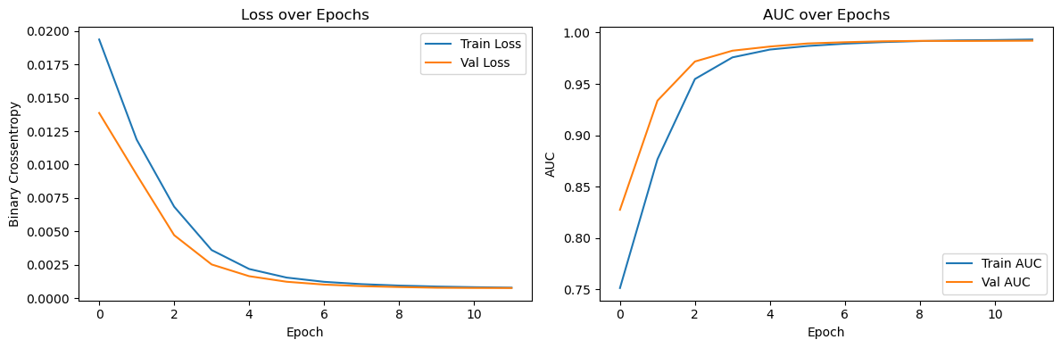

Figure 4.2: Training performance of Deep Knowledge Tracing (DKT) of student agent with question type encoding (DKT-Skill+QType).
Figures 4.1 and 4.2 illustrate the training dynamics for both DKT variants across 12 epochs, utilizing 80 per cent of the available sequences for training and reserving 20 per cent for validation, which was a division made feasible by the substantial size of our dataset
While both models demonstrated strong predictive performance, DKT-Skill surpassed DKT-Skill+QType in all metrics. DKT-Skill achieved a validation AUC of 0.9928, slightly outperforming DKT-Skill+QType, which reached 0.9920. This indicates that incorporating question type information offers negligible predictive benefit for modelling student performance. Examination of the training logs revealed that DKT-Skill+QType required substantially more computational resources during the early epochs, with approximately 200ms per step compared to 41ms for DKT-Skill, suggesting that the additional question type embeddings increase model complexity without providing proportional gains. Precision and recall metrics remained consistently high across both models, with final training precision and recall exceeding 0.987 and 0.9597, respectively. Overall, these results suggest that skill-based features alone sufficiently capture the essential patterns in student learning trajectories, and that encoding question type may introduce unnecessary complexity to the DKT architecture without meaningful improvements in knowledge tracing tasks.

Table 4.1: Performance comparison of DKT-Skill and DKT+QType models.
Model | Validation AUC | Validation Precision | Validation Recall
DKT-Skill | 0.9928 | 0.9911 | 0.9646
DKT-Skill+QType | 0.9920 | 0.9902 | 0.9622

4.2.1 Teacher Agent Evaluation
An ablation study was conducted over 200,000 timesteps of a 250-question sequence to evaluate the performance of three distinct policy optimization strategies: PPO-Random, PPO-Skill, and PPO-Skill+QType.
The PPO-Random model, which served as a performance baseline, exhibited a flat learning curve throughout the training process. It plateaued at an approximate reward of 67, confirming that a non-adaptive, random action selection strategy fails to learn an effective policy. In contrast, the PPO-Skill teacher agent, which selects only question skills, demonstrated significant learning. The model showed a steep learning gradient during the initial 50,000 timesteps before stabilizing at a final reward of 96.34. This result clearly indicates the substantial benefit of incorporating question skill selection into the question sequencing policy.
The most sophisticated model, PPO-Skill+QType teacher agent, which jointly considers both question skill and question type, achieved the highest final reward of 109.99. Notably, its learning curve did not plateau by the end of the training period. It maintained a positive trajectory throughout the full 200,000 timesteps. This suggests that the policy had not yet achieved full convergence and could potentially attain superior performance with extended training, such as 1-3 million timesteps. However, such extended training would necessitate substantial computational resources and significantly longer execution times, presenting practical constraints for implementation within the scope of this thesis. Although these findings still highlight that a fully adaptive policy incorporating content format, while more complex, leads to superior convergence and a higher overall reward ceiling.
The enhanced performance of the PPO-Skill+QType model was associated with increased computational cost. It required 15.11 hours for training, compared to 8.89 hours for PPO-Skill and 12.34 hours for PPO-Random. This computational overhead is attributable to the increased complexity of exploring the joint action space of both skills and question types. These results imply a trade-off, that while leveraging a comprehensive action space and state information is computationally intensive, it yields a more robust and effective policy when sufficient computational resources are available.

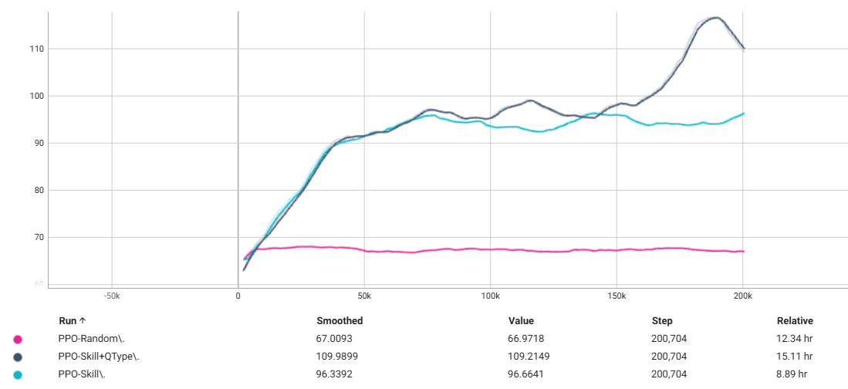

Figure 4.3: Reward performance of PPO teacher agent policies, i.e. PPO-Random, PPO-Skill and PPO-Skill+QType.
Figure 4.3 also shows that PPO-Skill+QType and PPO-Skill went through a similar reward curve for about 75,000 training timesteps, but while the baseline PPO-Random and the PPO-Skill models exhibited clear plateaus in performance, the reward curve for PPO-Skill+QType demonstrates a distinct upward trajectory in the final 40,000 timesteps of training. Correspondingly, in Figure 4.4, the PPO-Skill+QType model’s value loss, which represents the error in the teacher agent’s state-value predictions, had not stabilized by the end of the run. Its continued fluctuations suggest that the value function was still being actively refined to better estimate future rewards, which is a clear sign of an ongoing learning process.

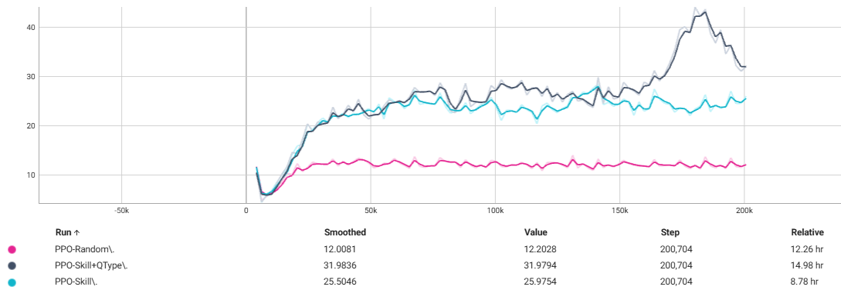

Figure 4.4: Value loss plot of PPO teacher agent policies.
Taken together, the positive slope in the reward curve and the unconverged nature of the value loss provide compelling evidence that the PPO-Skill+QType model’s learning process is incomplete. Given extended training, it is likely that the model would continue to improve, ultimately achieving a higher level of performance.

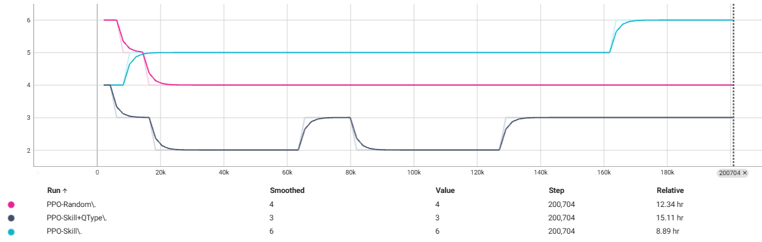

Figure 4.5: Time step per second graph of PPO teacher agent policies.

4.3 Research Objectives

4.3.1 Knowledge Tracing Performance
Contrary to our initial hypothesis that different question types would provide valuable contextual information for knowledge tracing, the results reveal that incorporating question type encoding (DKT-Skill+QType) offers minimal predictive benefits over the baseline skill-only model (DKT-Skill). The marginal difference in validation AUC (0.9928 vs 0.9920) suggests that question type information contributes negligibly to the model's ability to predict student understanding.
This finding indicates that the cognitive demands and conceptual requirements across different question types may be more similar than anticipated, or that skill-based features already capture the essential variations in question difficulty and conceptual complexity. The skill embeddings appear to encapsulate sufficient information about the underlying knowledge components required for successful performance, regardless of the specific question format or type.

4.3.2 Learning Gains Analysis
To address our research question of whether a reinforcement learning model can adaptively select and sequence question types to improve student performance over time, we evaluated the three distinct PPO approaches against student performance trajectories. The running average performance curves presented in Figure 4.6 provide clear evidence of the RL model's adaptive capabilities and the relative effectiveness of different information encoding strategies.
We employed running average performance metrics rather than raw DKT outputs to evaluate our RL system because DKT models provide probabilistic predictions of student correctness that can be highly variable on individual questions. This phenomenon is also evident in Figure 4.6, where the DKT model demonstrates difficulty in establishing reliable student knowledge estimates until approximately the 50th question in the sequence, which corresponds to the sequence length utilized in our DKT preprocessing and modelling framework. The running average smooths these predictions over sequential interactions, providing a more stable and interpretable measure of student learning progress over time. This approach allows us to assess whether the RL agent's question selection strategies are producing sustained improvements in predicted student performance rather than capitalizing on short-term fluctuations in the DKT model's outputs.

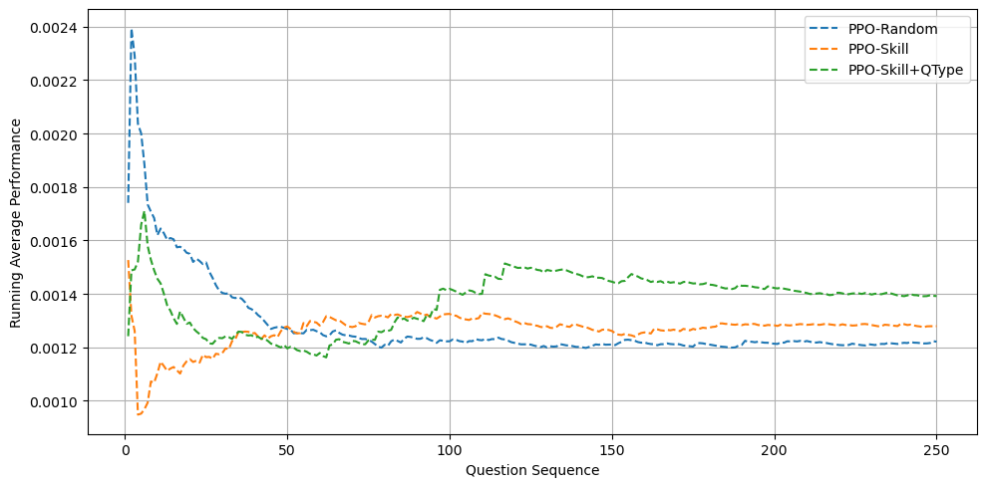

Figure 4.6: Running average performance of student agent on sequenced questions by teacher agent PPO policies.

The results demonstrate clear differentiation between the three PPO approaches. Due to DKT variability in outputs during the initial sequence establishment phase, we analyse the student agent's performance starting from the 50th question onwards, where more reliable knowledge state estimates are available.

From the 50th question onward, the PPO-Random baseline maintains relatively stable but suboptimal performance, oscillating around 0.0012-0.0013 throughout the remaining sequence with slight fluctuations but no clear improvement trajectory. This pattern suggests that random question selection provides limited sustained benefit for student learning progression and lacks the adaptive mechanisms necessary for continuous improvement.

In contrast, both adaptive RL approaches demonstrate more stable performance trajectories from the 50th question onwards. PPO-Skill maintains consistently slightly higher running average performance, stabilizing around 0.0013 after question 50 and showing remarkable stability throughout the 250-question sequence with minimal performance degradation. Most notably, PPO-Skill+QType achieves the highest sustained performance among all approaches, maintaining elevated performance around 0.0014-0.0015 from question 50 onwards, with a notable peak around question 100-120 reaching approximately 0.0015, before stabilizing at approximately 0.0014 for the remainder of the sequence, consistently outperforming both alternative approaches.

The performance curves provide compelling evidence that our RL model can indeed adaptively select and sequence question formats to improve student outcomes. The sustained performance shows advantages of both PPO-Skill and PPO-Skill+QType over the random baseline, indicating that the RL agent successfully learns to identify optimal question selection patterns that promote better student performance over extended learning sessions.

Particularly significant is the trajectory of PPO-Skill+QType, which shows continued improvement through approximately 150 questions before stabilizing, suggesting that the inclusion of question type information enables more sophisticated adaptive strategies. This gradual improvement pattern indicates that the RL agent learns to sequence question types in ways that build upon previous learning, rather than simply selecting question formats indiscriminately.

4.3.3 Question Type Personalization

The superior performance of PPO-Skill+QType indicates that the RL agent successfully learns to strategically utilize different question types to enhance student learning outcomes. While our knowledge tracing evaluation showed minimal predictive benefits from question type encoding, the RL context reveals that question type diversity provides valuable strategic information for creating personalized learning sequences. This finding suggests that we need to investigate further how it personalizes such data compared to other policies.

The heatmap visualizations in Figures 4.7, 4.8 and 4.9 reveal distinct question selection patterns that demonstrate how multi-type sequencing enables more sophisticated personalization strategies. The PPO-Random baseline shows relatively uniform distribution across question types and skills, with no discernible strategic patterns. In contrast, both PPO-Skill and PPO-Skill+QType exhibit clear selective preferences, with concentrated activity in specific skill-question type combinations that suggest learned optimization strategies.
Most notably, PPO-Skill+QType demonstrates the most refined selection patterns, with highly concentrated selections in specific skill areas in Figure 4.9 and more strategic distribution across question types. This concentrated activity pattern indicates that the RL agent has learned to identify optimal skill-question type pairings that maximize learning effectiveness, representing a higher level of personalization than random or skill-only approaches.
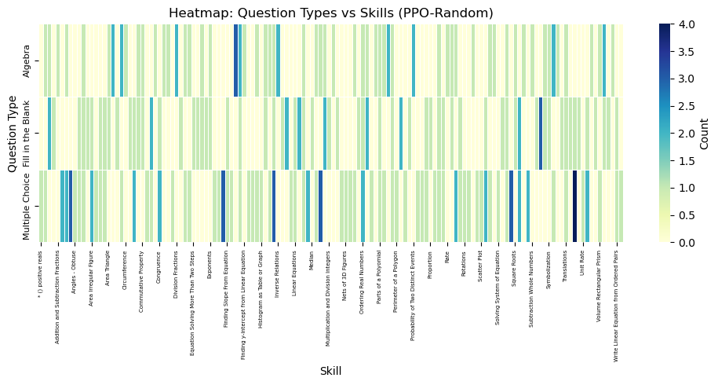

Figure 4.7: Question type vs skill heatmap of sequenced questions by teacher agent with a random PPO policy.
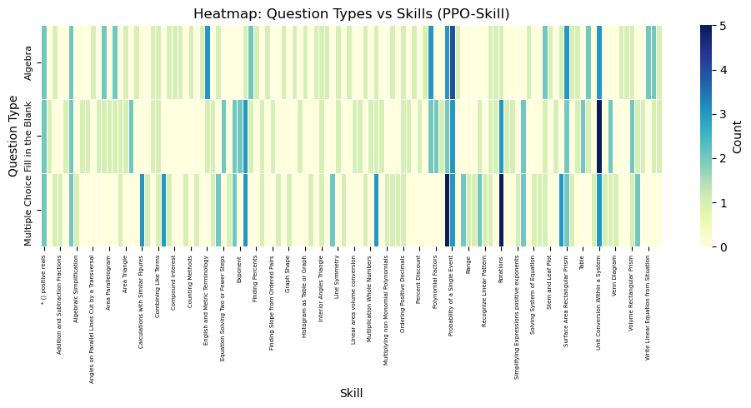

Figure 4.8: Question type vs skill heatmap of sequenced questions by teacher agent with skill-based PPO policy.
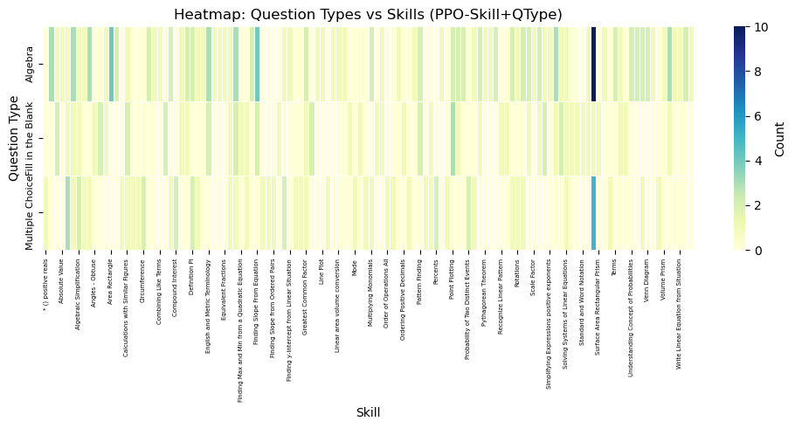

Figure 4.9: Question type vs skill heatmap of sequenced questions by teacher agent with skill and question type-based PPO policy.
The pie chart distributions of PPO policies question type selection in Figure 4.10 provide compelling evidence that multi-type question sequencing leads to fundamentally different and more strategic question selection patterns. The PPO-Skill+QType approach shows a marked preference for algebra questions of 52.4% while significantly limiting fill-in-the-blank questions to 24.0% and multiple choice to 23.6%. This pronounced shift indicates the prevalence of algebra question interactions learned from the data and suggests that the RL agent has recognized that algebra questions offer optimal learning benefits when strategically sequenced according to skill-based considerations.
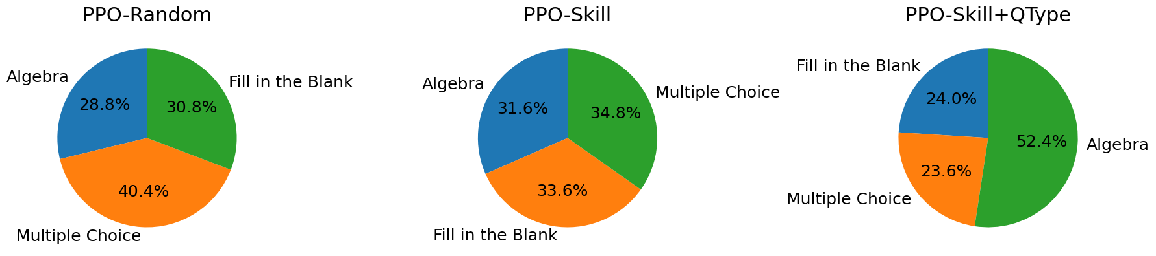

Figure 4.10: Question type distribution of sequenced questions by teacher agent PPO policies.

Chapter 5

Discussion

5.1 Interpretation of Results
The results of this study provide nuanced insights into the effectiveness of skill-based KT architectures and RL strategies in adaptive learning systems. Our findings indicate that skill-based knowledge tracing architectures are inherently robust and capable of accurately modelling student knowledge state transitions. The minimal contribution of question type encoding to predictive performance suggests that skill-level representations alone capture the essential patterns of student learning. This implies that, for binary correctness prediction, the complexity introduced by incorporating question metadata is largely unnecessary, as the skill-based representation sufficiently models cognitive processes underlying student performance.
In contrast, our RL experiments reveal a distinct pattern. While question type information does not substantially enhance KT predictive accuracy, it significantly improves RL agent performance in adaptive question sequencing. PPO-Skill+QType consistently outperforms PPO-Skill, with approximately 8% higher running average performance in stable regions. This demonstrates that the RL agent can exploit question format diversity to optimize learning sequences, even when predictive models do not show measurable gains from this information. These results highlight the divergent roles of question format information, suggesting it has limited predictive utility for KT but provides strategic value for adaptive sequencing in RL contexts.

5.2 Practical and Theoretical Implications
From a practical standpoint, the findings suggest that adaptive learning systems should prioritize accurate skill decomposition, as demonstrated through question-specific representations using question-centric deep knowledge tracing (qDKT) (Sonkar et al., 2020), rather than relying primarily on question type metadata for knowledge tracing. Traditional KT architectures that focus on skill-level features can achieve high predictive accuracy while reducing model complexity and computational overhead.
Conversely, the RL results underscore the importance of integrating multi-dimensional input features, by including question formats, into adaptive sequencing algorithms. The superior performance of PPO-Skill+QType illustrates that RL agents can exploit diverse question types to construct personalized and strategically effective learning sequences. The agent's preference for algebra questions demonstrates that multi-type sequencing can optimize practice opportunities for areas where students require the most support. Concentrated activity patterns in specific skill domains, as observed in the heatmaps, further reinforce the advantage of multi-type approaches in enabling targeted and intensive learning experiences.
Theoretically, this study emphasizes that the utility of features in adaptive learning models depends on the task context. Skill-based representations are central for modelling student knowledge transitions, while question type information serves a complementary role in guiding pedagogical strategies and decision making in RL frameworks. These insights advance the understanding of how knowledge tracing and reinforcement learning can be synergistically integrated to enhance adaptive learning personalization.

5.3 Limitations
Several limitations must be acknowledged. First, the dataset may have lacked sufficient diversity in question types as it was limited to only three question types, potentially underestimating the benefits of question type encoding in knowledge tracing. Future studies could explore richer datasets and more sophisticated question format representations, such as GKT and qDKT, to further investigate how question format features contribute to predictive value.
Secondly, the interaction effects between skills and question types were not fully examined in this study. Although RL agents demonstrated improved performance with question-type information, further research is needed to quantify how specific question types interact with skills to maximize learning gains. Additionally, the RL experiments were conducted in a controlled simulation environment, and real-world educational settings may present additional variability that could affect performance outcomes.
Finally, while this study demonstrates the potential of skill-based KT and RL multi-type question sequencing, the generalizability of these findings to other subjects, learning levels, or diverse student populations remains to be empirically validated. Future work should investigate these methods across diverse contexts to confirm their broader applicability.

Chapter 6

Conclusion and Future Works

6.1 Conclusion
In essence, while question format may have limited predictive utility for what a student knows, it offers significant pedagogical value for how a student learns. These findings have important implications for the design of next-generation adaptive tutoring systems, highlighting that the true power of personalization lies in strategically sequencing not just the content, but also the format of educational interactions.

6.2 Future Directions
The findings of this thesis open several promising avenues for future research to build upon the established framework and address its current limitations in question or educational formats in student modelling and RL techniques.

6.2.1 Enhanced Student and System Modelling
A primary avenue for future research involves the development of more sophisticated student modelling approaches. The current knowledge tracing framework could be significantly enhanced through the incorporation of multi-modal data sources, including response latency, question attempt frequency, hint utilization patterns, and partial credit scoring mechanisms, thereby enabling more comprehensive representations of student knowledge states. The implementation of hierarchical skill modelling architectures, such as GKT, would explicitly capture prerequisite relationships and conceptual dependencies, facilitating more pedagogically informed sequencing decisions that align with natural learning progressions. Additionally, future modelling efforts should extend beyond purely cognitive assessments to encompass metacognitive dimensions, incorporating measures of student confidence, motivation, and self-regulatory behaviours to create more holistic learner profiles that better reflect the complexity of human learning processes.
From a tutoring environment perspective, this approach could further enhance RL architectures. RL agents could make more informed high-level strategic decisions about learning objectives, along with low-level decisions on how learning formats are delivered to students. Investigating multi-agent RL could simulate collaborative learning environments, while developing transfer learning techniques would enable the system to adapt more rapidly to new educational domains and diverse student populations.

6.2.2 Expanded Educational Content Type and Real-World Application
The current system relies on a predefined question bank with limited formats. Future iterations should expand to include more complex and diverse question types, which would require integrating advanced NLP techniques for automated scoring and feedback. Additionally, the system could be enhanced by incorporating richer educational content, such as videos, audio, and diagrams, enabling adaptive content generation for sequence learning materials to learners.
Crucially, this research must move from simulation to practice. Large-scale field studies in real classroom settings are essential to validate the findings with diverse student populations. Such studies would provide invaluable data on long-term effectiveness, user engagement, and the practical challenges of implementation. This would also allow for cross-cultural validation to ensure the system's pedagogical strategies are effective across different learning contexts.
As adaptive systems become more powerful, addressing their ethical implications is paramount. Future research must focus on algorithmic fairness and bias mitigation to ensure equitable outcomes for all students. Developing privacy preserving techniques, such as federated learning, will be critical for protecting sensitive student data. Additionally, improving the transparency and explainability of the RL agent’s decisions is necessary to foster trust among educators, students, and parents. Finally, future work should focus on integrating these systems into the broader educational ecosystem, ensuring alignment with school curricula and providing professional development to help teachers leverage these powerful new tools effectively.

References
Anthropic, 2025. Large language model. Sonnet 4.
Baker, R.S.J.D., Corbett, A.T., Aleven, V., 2008. More Accurate Student Modeling Through Contextual Estimation of Slip and Guess Probabilities in Bayesian Knowledge Tracing.
Bayly-Castaneda, K., Ramirez-Montoya, M.S., Morita-Alexander, A., 2024. Crafting personalized learning paths with AI for lifelong learning: a systematic literature review. Front Educ (Lausanne).
Chen, J.-Y., Saeedvand, S., Lai, I.-W., 2023. Adaptive Learning Path Navigation Based on Knowledge Tracing and Reinforcement Learning.
Chen, Y., Wu, L., Zaki, M.J., 2020. Reinforcement Learning Based Graph-to-Sequence Model for Natural Question Generation.
Choi, Y., Lee, Y., Cho, J., Baek, J., Kim, B., Cha, Y., Shin, D., Bae, C., Heo, J., 2020. Towards an Appropriate Query, Key, and Value Computation for Knowledge Tracing. In: L@S 2020 - Proceedings of the 7th ACM Conference on Learning @ Scale. Association for Computing Machinery, pp. 341–344.
Gervet, T., Koedinger, K., Schneider, J., Mitchell, T., 2020. When is Deep Learning the Best Approach to Knowledge Tracing?
Graf, S., Liu, T.-C., 2009. Supporting Teachers in Identifying Students’ Learning Styles in Learning Management Systems: An Automatic Student Modelling Approach, Educational Technology & Society.
Guan, M., Mondal, S.K., Dai, H.-N., Bao, H., Kumar Mondal, S., 2023. Highlights Reinforcement Learning-Driven Deep Question Generation with Rich Semantics Reinforcement Learning-Driven Deep Question Generation with Rich Semantics.
Hadifar, A., Bitew, S.K., Deleu, J., Develder, C., Demeester, T., 2023. EduQG: A Multi-Format Multiple-Choice Dataset for the Educational Domain. IEEE Access 11, 20885–20896.
Immekus, J.C., Snyder, K.E., Ralston, P.A., 2019. Multidimensional Item Response Theory for Factor Structure Assessment in Educational Psychology Research. Front Educ (Lausanne) 4.
Joshi, M., 2023. Adaptive Learning through Artificial Intelligence. SSRN Electronic Journal.
Kevin, A., Bakker, M., van Loon, A.M., Kral, M., Camp, G., 2025. Young learners’ motivation, self-regulation and performance in personalized learning. Comput Educ 226.
Khajah, M., Lindsey, R. V, Mozer, M.C., 2014. How Deep is Knowledge Tracing?
Kulshreshtha, D., Shayan, M., Belfer, R., Reddy, S., Serban, I.V., Kochmar, E., 2022. Few-shot Question Generation for Personalized Feedback in Intelligent Tutoring Systems.
Le, N.T., Kojiri, T., Pinkwart, N., 2014. Automatic question generation for educational applications - the state of art. Advances in Intelligent Systems and Computing 282, 325–338.
Li, Z., Yang, J., Wang, J., Shi, L., Stein, S., 2024. Integrating LSTM and BERT for Long-Sequence Data Analysis in Intelligent Tutoring Systems.
Minn, S., 2021. BKT-LSTM: Efficient Student Modeling for knowledge tracing and student performance prediction.
Mulla, N., Gharpure, P., 2023. Automatic question generation: a review of methodologies, datasets, evaluation metrics, and applications. Progress in Artificial Intelligence.
Nakagawa, H., Iwasawa, Y., Matsuo, Y., 2019. Extracting and Exploiting Latent Knowledge Structure by Graph-based Knowledge Tracing.
Papamitsiou, Z., Economides, A.A., 2014. Learning Analytics and Educational Data Mining in Practice: A Systematic Literature Review of Empirical Evidence, Educational Technology & Society.
Pastor, D.A., Barron, K.E., Miller, B.J., Davis, S.L., 2007. A latent profile analysis of college students’ achievement goal orientation. Contemp Educ Psychol 32, 8–47.
Piech, C., Spencer, J., Huang, J., Ganguli, S., Sahami, M., Guibas, L., Sohl-Dickstein, J., 2015. Deep Knowledge Tracing.
Rafferty, A.N., Ying, H., Williams, J.J., 2019. Statistical Consequences of using Multi-armed Bandits to Conduct Adaptive Edu-cational Experiments, Journal of Educational Data Mining.
Schmucker, R., Pachapurkar, N., Bala, S., Shah, M., Mitchell, T., 2025. Learning to Optimize Feedback for One Million Students: Insights from Multi-Armed and Contextual Bandits in Large-Scale Online Tutoring.
Segal, A., Williams, J.J., David, Y. Ben, Gal, K., Shalom, Y., 2018. Combining Difficulty Ranking with Multi-Armed Bandits to Sequence Educational Content.
Shchepakin, D., Sankaranarayanan, S., Zimmaro, D., 2023. Parametric Constraints for Bayesian Knowledge Tracing from First Principles.
Sonkar, S., Waters, A.E., Lan, A.S., Grimaldi, P.J., Baraniuk, R.G., 2020. qDKT: Question-centric Deep Knowledge Tracing.
Tahiru, F., 2021. AI in education: A systematic literature review. Journal of Cases on Information Technology.
Wang, H., Zariphopoulou, T., Yu Zhou, X., 2019. Exploration versus exploitation in reinforcement learning: a stochastic control approach.
Xiao Li, Hanchen Xu, Jinming Zhang, Hua-hua Chang, 2020. DEEP REINFORCEMENT LEARNING FOR ADAPTIVE LEARNING SYSTEMS.
Xiong, X., Zhao, S., Van Inwegen, E.G., Beck, J.E., 2016. Going Deeper with Deep Knowledge Tracing.
Yang, Y., Shen, J., Qu, Y., Liu, Y., Wang, K., Zhu, Y., Zhang, W., Yu, Y., 2020. GIKT: A Graph-based Interaction Model for Knowledge Tracing.
Zhang, H., Bu, C., Liu, F., Liu, S., Zhang, Y., Hu, X., 2022. APGKT: Exploiting Associative Path on Skills Graph for Knowledge Tracing.

